Attruby® Product Module

Contents
How to Use This Module 4
Introduction 5
Welcome 5
Module Summary 5
Module Learning Objectives 5
Chapter 1: Attruby, TTR Tetramer Stabilization, and ATTR-CM 7
Learning Objectives 7
Section 1.1: Attruby Description and Indication 7
Section 1.2: Role of TTR Destabilization in ATTR-CM 8
Section 1.3: Overview of ATTR-CM Clinical Consequences 9
Key Concepts 12
Check Your Progress 13
Answers 14
Chapter 2: Attruby Dosage and Administration, Contraindications, Adverse Reactions, Drug Interactions, and Use in Specific Populations 15
Learning Objectives 15
Section 2.1: Attruby Dosage, Administration, and Contraindications 15
Section 2.2: Adverse Reactions and Drug Interactions 16
Section 2.3: Use in Specific Populations 17
Section 2.4: How Supplied, Storage and Handling, and Patient Support Program 19
Key Concepts 21
Check Your Progress 23
Answers 25
Chapter 3: Clinical Pharmacology, Nonclinical Toxicology, and Clinical Efficacy 26
Learning Objectives 26
Section 3.1: Attruby Mechanism of Action 26
Section 3.2: Key Clinical Pharmacology Attributes 27
Section 3.2: ATTRibute-CM Design and Patient Population 30
Section 3.3: ATTRibute-CM Efficacy Results 33
Section 3.4: Open-Label Extension (OLE) 39
Key Concepts 42
Check Your Progress 44
Answers 46
Glossary 47
References 51

How to Use This Module
This module is divided into chapters and sections. Each chapter begins with a list of Learning Objectives (LOs) that describe what you can expect to learn in that chapter. Medical terminology is highlighted in boldface type and defined in the Glossary at the end of the module.
At the end of each chapter, a list of Key Concepts summarizes important points. After reading each chapter, review the Key Concepts, then complete the Check Your Progress questions and check your answers against those provided. If you are unable to answer the questions without referring to the answer guide, review the chapter before continuing your study of this module.
A variety of callout boxes are located throughout this module to highlight key topics and provide additional information:
Interactivity: Callout
⊕ ZOOM IN
These callouts provide the learner with a more in-depth look at selected topics. All callouts should be styled like this.
Interactivity: Callout
★ QUICK FACT!
These callouts point out facts relevant to a topic discussed in the text. All callouts should be styled like this.

Introduction

Welcome
This module focuses on the key properties and attributes of Attruby® (acoramidis) and its safety and efficacy in the treatment of transthyretin amyloidosis cardiomyopathy (ATTR-CM). [Attruby PI p2/A] ATTR-CM is a rare, progressive infiltrative cardiomyopathy resulting from destabilization of the transthyretin (TTR) tetramer protein, which allows the tetramer to dissociate into its constituent monomers which reform into toxic amyloid fibrils, leading to the accumulation of TTR amyloid fibrils in the myocardium. [Kittleson 2020 p e7/A, e8/A.B, p e11/A, p e13/A][Garcia-Pavia 2021 p896/B][Kittleson 2023 p1081/A] Attruby is a near-complete TTR stabilizer (≥90%) approved by the US Food and Drug Administration (FDA) to reduce cardiovascular death and cardiovascular-related hospitalization (CVH) in adult patients with ATTR-CM. [Gillmore 2024 p133/A,B][Penchala 2013 p9996/A][Judge 2019 p289/A][Attruby PI p2/A] Stabilizing the TTR tetramer has become an important therapeutic target for slowing ATTR-CM progression. [Morfino 2023 p7/A]

Module Summary
The content presented in this module expands beyond the efficacy and safety information provided in the labelling to include additional data from approved sources. This information will help you better communicate when discussing Attruby.
- Chapter 1 provides an overview of ATTR-CM, introduces Attruby, states its indication, and describes the consequences of ATTR-CM and delays in diagnosis
- Chapter 2 describes the dosage and administration, contraindications, adverse reactions and laboratory test changes observed during Attruby clinical trials, drug interactions, use in specific populations, how Attruby is supplied, storage and handling, and key features of the ForgingBridges® support program
- Chapter 3 describes the clinical pharmacology of Attruby, including pharmacodynamics, nonclinical toxicology, and efficacy data from the ATTRibute-CM phase 3 study which includes data from the pivotal study and post-hoc analyses

Module Learning Objectives
Upon completion of this module, learners will be able to:
- Describe the key attributes of Attruby and its role in TTR tetramer stabilization
- Describe the dosing and administration of Attruby, and discuss its safety and tolerability
- Explain clinical study data supporting the effectiveness of Attruby in improving outcomes in patients with ATTR-CM and outline the key features of the patient and provider support program, ForgingBridges

Interactivity: Callout
Disclaimer
For Internal Learning and Education Only.
Content may not be disseminated or discussed with healthcare professionals (HCPs) or externally outside of BridgeBio or Affiliates.
Do not duplicate or modify these materials.

Chapter 1: Attruby, TTR Tetramer Stabilization, and ATTR-CM

Learning Objectives
Interactivity: Accordion
Upon completion of this chapter, learners will be able to:
Describe Attruby and state its indication
Describe the role of TTR destabilization in ATTR-CM
Explain the key clinical consequences of ATTR-CM

Section 1.1: Attruby Description and Indication
Attruby® (acoramidis) is a transthyretin (TTR) stabilizer that stabilizes the TTR protein tetramer. [Attruby PI p4/A] TTR stabilizers are a type of disease-modifying treatment for transthyretin amyloidosis cardiomyopathy (ATTR-CM) that binds to the TTR tetramer and impedes TTR protein misfolding, thereby preventing the deposit of amyloid fibrils. [Kittleson 2020 p e11/A]
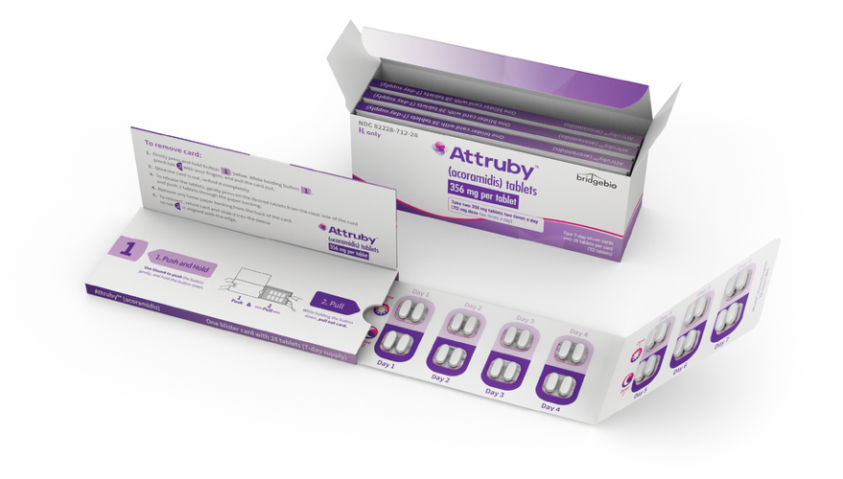
Figure 1-1: Attruby Package [Source: https://www.drugs.com/images/pills/custom/pill36432-1/attruby.jpg]
Attruby is indicated for the treatment of the cardiomyopathy of wild-type or variant transthyretin-mediated amyloidosis (ATTR-CM) in adults to reduce cardiovascular death and cardiovascular-related hospitalization (CVH). [Attruby PI p2/F] Learning about the clinical studies supporting the use of Attruby in appropriate patients with ATTR-CM will help you better communicate the attributes of Attruby.

Section 1.2: Role of TTR Destabilization in ATTR-CM

TTR Structure and Function
The TTR protein is structured as a tetramer formed from monomers. [Ruberg 2019 p2875 Fig 1/A; p2873/C][Vieira 2014 p45/D][Santanna 2017 p1/A][Penchala 2013 p9992/A][Sanguinetti 2022 p4/B,C] Two monomers form hydrogen bonds to create a dimer. A weak interface between 2 dimers creates the TTR tetramer. The dimer-to-dimer interface forms a pocket with binding locations. The TTR protein tetramer structure is kinetically stabilized by the binding of thyroxine to its binding site. [Sanguinetti 2022 p4/A, B,C, Figure 1][Vieira 2014 p45/D][Santanna 2017 p1/A][Penchala 2013 p9992/A][Ruberg 2019 p2875 Fig 1/A; p2873/C]
Serum TTR (sTTR) is also known as prealbumin and functions as a carrier protein for 2 substances that have important physiologic functions: [Morfino 2023 p1/A, p2/A][Liz 2020 p396/A][prealbumin Tabers p1/A][Vieira 2014 p45/A,B, p47/A][Sanguinetti 2022 p2/C]
- Retinol binding protein (RBP), which is the transport protein for vitamin A (retinol): Circulating TTR is mostly involved in the transport of RBP complexed with vitamin A; vitamin A is important for vision, immunity, and neurologic function; deficiency in vitamin A can lead to ocular symptoms such as night blindness
- Thyroxine (T4): Critical hormone in metabolic regulation; only a small portion of circulating TTR is involved in the transport of thyroxine
Thyroid hormones, including thyroxine, have essential roles in development, tissue differentiation, and regulation of metabolism in the body. [Vieira 2014 p46/A]
Interactivity: Hot Spots
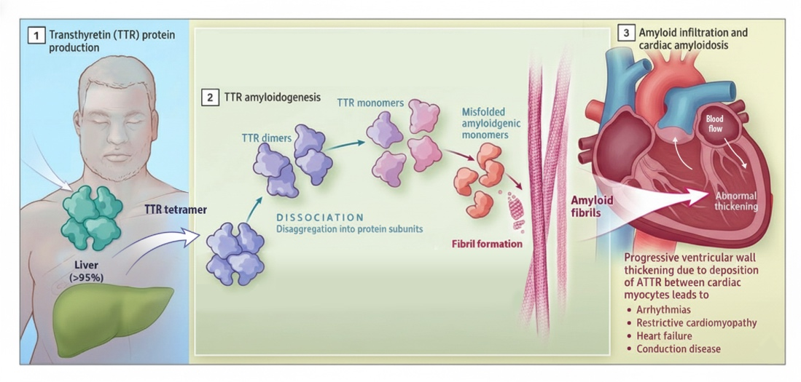
Adapted from Ruberg FL, Maurer MS. Cardiac amyloidosis due to transthyretin protein. JAMA. 2024;331(9):778-791. doi:10.1001/jama.2024.0442
Hot spot 1: Loss of tetramer stability can lead to ATTR-CM. [Morfino 2023 p1/A, p3/A,B,C][Liz 2020 p396/E]
TTR is a naturally occurring protein; an estimated 95% of TTR is synthesized in the liver. [Liz 2020 p396/A, p397/A][Vieira 2014 p45/A, B][Niemetz 2015 p17947/A] TTR performs its functions only when present and stable. [Liz 2020 p396/A, p397/A][Vieira 2014 p45/A, B]
Hot spot 2: Loss of TTR stability is the initial event in ATTR-CM. [Morfino 2023 pB][Liz 2020 p396/B,E]
Aging or genetic variation can cause TTR to destabilize and break apart into monomers. [Kittleson 2023 p1081/A][Morfino 2023 p3/C]
Hot spot 3: Misfolded monomers aggregate into toxic amyloid fibrils. [Kittleson 2023 p1081/A][Morfino 2023 p3/A]
These fibrils accumulate throughout the body, including in the myocardium. [Morfino 2023 p3/B, 5/A][Liz 2020 p396/B,E][Kittleson 2025 p3/A, p5/A]
Accumulation of amyloid deposits in the ventricular wall leads to thickening and eventually results in cardiac dysfunction. [Ruberg 2024 p18/A Figure 1]
Stabilizing the TTR tetramer has become an important therapeutic target for slowing ATTR-CM progression. [Morfino 2023 p7/A] By preserving the structure of the TTR protein tetramer and thereby slowing down the formation and accumulation of toxic amyloid fibrils in the body’s organs, including the heart, TTR stabilizers may help alter the natural course of the disease. [Morfino 2023 p3/A, p7/A][Gertz 2015 p2462/A][Kittleson 2025 p7/A]

Section 1.3: Overview of ATTR-CM Clinical Consequences
ATTR-CM is a life-threatening, progressive heart disease that negatively impacts patients. [Gertz 2015 p2453/A, B][Stewart 2018 p353/A, p354/A, p355/A, p360/B]
There are 2 forms of ATTR-CM: [Kittleson 2025 p3/B]
Interactivity: Tabs
Tab 1: Wild-type ATTR-CM (ATTRwt-CM)
ATTRwt-CM is caused by TTR destabilization due to aging [Ruberg 2024 p2/A]
Typically presents later in life but often remains undiagnosed for years; ATTRwt-CM is a slower progressing version of the disease [Ruberg 2024 p4/A][Ruberg 2029 p2875/A,B]
Tab 2: Variant ATTR-CM (ATTRv-CM)
ATTRv-CM is caused by TTR gene mutations [Ruberg 2024 p2/A]
May present earlier; associated with faster disease progression and more aggressive cardiac disease [Boda 2022 p658/A, p659/A,B, C, D, E, p661/A]
In the US, the V122I mutation is carried by approximately 3.5% of community-dwelling Americans of African/Caribbean descent. [Ruberg 2024 p4/A][Buxbaum 2018 p2/A, p19 Table 1/A] Note that having the V122I mutation does not mean the carrier has ATTR-CM.

Effects of Variants on TTR Stability
Different TTR variants can lead to different clinical manifestations, and mutations with more destabilizing effects on TTR may lead to more severe disease. [Kittleson 2023 p1091 Table 3/B][Sant'anna 2017 p10/A]
- The V30M mutation thermodynamically destabilizes the TTR tetramer. [Kittleson 2023 p1095/A, p1091/B]
- The T60A mutation is found among persons of Irish descent, particularly in the Appalachian region of the US. [Obi 2022 p20/A] This variant presents with both neurologic and cardiac manifestations. [Obi 2022 p20/A][Bhatt 2024 p5/A]
- V122I kinetically destabilizes the TTR protein tetramer, which dissociates twice as rapidly as wild-type TTR. V122I is predominantly associated with ATTR-CM; autopsy studies have shown V122I leads to pathogenic changes associated with ATTR-CM in nearly 100% of patients who are carriers. [Kittleson 2023 p1093/A, p1095/B] The variant V122I is the most common cause of ATTRv-CM in the US. [Kittleson 2023 p1091/B, p1092/B]
- The T119M mutation stabilizes the TTR protein tetramer. [Sanguinetti 2022 p7/A][Penchala 2013 p9992/B] The stabilizing effect of the T119M mutation protects the TTR tetramer against both dissociation and aggregation. [Sant'Anna 2017 p3/A] The T119M mutation appears to reduce the symptoms of ATTR in people who inherit a disease-causing TTR mutation along with a normal TTR gene. [Sant'Anna 2017 p2/A,B]

ATTR-CM Clinical Manifestations
ATTR-CM can present as a variety of cardiac and extracardiac symptoms: [Maurer 2019 p2/A][Kittleson 2023 p1083/A Table 1, p1090/A][Griffin 2021 p491/A][Ruberg 2024 p5/A]
- Shortness of breath
- Tiredness or weakness
- Swelling in legs and feet
- Irregular heartbeat
- Gastrointestinal problems
- Bilateral carpal tunnel syndrome
Symptoms can mirror other serious conditions or appear unrelated to a heart condition. [Kittleson 2020 p e8/E][Kittleson 2025 p5/B]
Without early intervention, ATTR-CM may lead to:
- Earlier mortality [Lauppe 2022 p2533/A]
- Increased cardiovascular-related hospitalization (CVH) [Lane 2019 p3/A][Steward 2018 p355/B]
- Significantly impaired quality of life [Gertz 2015 p2453/A][Stewart 2018 p353/A][Lane 2019 p14/A]
- Reduced functional capacity [Stewart 2018 p354/A, 355/A, p360/A]
ATTR-CM is prevalent in patients with certain comorbidities, including but not limited to aortic stenosis with valve replacement (16%) and heart failure with preserved ejection fraction (HFpEF) (6%–15%): [Kittleson 2023 p1079/H][Kim 2023 p1/A][Tziomalos 2025 p3/A]
Interactivity: Callout
⊕ ZOOM IN: Diagnosis Challenges in ATTR-CM
The presence of nonspecific symptoms is why ATTR is sometimes referred to as “the great imitator” because its clinical presentation has no specific defining symptoms and may be mistakenly attributed to other conditions. [Shaker 2022 p2/A][Kittleson 2020 p e8/C][Witteles 2019 p711/A] Because many patients remain undiagnosed, the total population with ATTR-CM remains unknown. [Kittleson 2020 p1079/D][Hafeez 2020 p86/A]
In a real-world, retrospective, observational cohort study from May 2018 to October 2022, patients showed signs of ATTR-CM progression as defined by: [Fontana 2025 p1/A, B; p2/A, B, C]
Interactivity: Tabs
Tab 1: Worsening biomarkers
NT-proBNP (N terminal prohormone of brain natriuretic peptide)
eGFR (estimated glomerular filtration rate)
Tab 2: Declining outcomes
Cardiac worsening
Cardiovascular-related hospitalization (CVH)
In addition, some evidence suggests sTTR levels may be a biomarker of TTR destabilization, and lower sTTR levels may be associated with worsening cardiac outcomes. [Christofferson 2024 p E4/A,B, p E6/A]

Delayed Diagnosis of ATTR-CM: Impact on Patients
Disease progression in untreated ATTR-CM is rapid, leading to significantly impaired functioning in patients, progression of clinical manifestations, irretrievable loss of quality of life, and a risk of death within 2 to 5 years of ATTR-CM diagnosis. [Nativi Nicolau 2021 p786/B, C]
Patients often develop musculoskeletal symptoms of ATTR-CM 5 to 15 years before the disease is diagnosed, and experience shoulder, knee, and hip pain, bicep tendon rupture, back pain, spinal stenosis, bilateral carpal tunnel syndrome, and undergo orthopedic surgeries. [Nativi Nicolau 2021 p789/A] Studies have found that patients with ATTR-CM are significantly more likely to undergo orthopedic surgery than the general population, and joint surgery typically precedes an ATTR-CM diagnosis by 6 to 8 years. [Nativi Nicolau 2021 p790/A]
Failure to accurately diagnose ATTR-CM can also lead to inappropriate treatment; patients with misdiagnosed ATTR-CM can be subjected to chemotherapy for immunoglobulin light chain (AL) amyloidosis or therapy with immunoglobulins or steroids for immune diseases. [Nativi Nicolau 2021 p786/A]
Early recognition and diagnosis of ATTR-CM is imperative for patients because ATTR is now a treatable disease, and early treatment will make a meaningful impact on a patient’s quality of life, autonomy, and physical function. [Nativi Nicolau 2021 p791/A]

Key Concepts
Interactivity: Accordion
Accordion 1: Attruby Description and Indication
Attruby® (acoramidis) is a TTR stabilizer that stabilizes the TTR protein tetramer. [Attruby PI p4/A]
Attruby is indicated for the treatment of the cardiomyopathy of wild-type or variant transthyretin-mediated amyloidosis (ATTR-CM) in adults to reduce cardiovascular death and CVH [Attruby PI p2/F]
TTR stabilizers belong to a group of disease-modifying therapies for ATTR-CM [Kittleson 2020 p e11/A]
Accordion 2: Role of TTR Protein Tetramer Destabilization in ATTR-CM
ATTR-CM is a disease of TTR tetramer destabilization [Morfino 2023 p1/A, p3/A,B][Liz 2020 p396/E]
Lower TTR levels have been associated with worsening outcomes; [Greve 2021 p259/A,B][Hanson 2018 p5/A] some evidence suggests low sTTR concentrations may be a marker of tetramer instability [Greve 2021 p263/A]
Accordion 3: Overview of ATTR-CM Clinical Consequences
ATTR-CM is a debilitating, life-threatening, progressive cardiac disease that has multiple negative effects on patients [Gertz 2015 p2453/A, B][Stewart 2018 p353/A, p354/A, p355/A, p360/B][Lane 2019 p14/A][Kittleson 2020 p e7/A, e8/A.B, p e11/A, p e13/A][Garcia-Pavia 2021 p896/B]
Key clinical consequences of ATTR-CM include premature death, [Lauppe 2022 p2533] a severely impaired quality of life and functional capacity, [Gertz 2015 p2453/A][Stewart 2018 p353/A, p354/A, p355/A, p360/A][Lane 2019 p14/A] and increased hospitalization [Lane 2019 p3/A][Stewart 2018 p355/B]

Check Your Progress
- Attruby is a transthyretin (TTR) __________.
- modifier
- silencer
- blocker
- stabilizer
- Which of the following completes the correct indication for Attruby? Attruby is indicated for the:
- prevention of the cardiomyopathy of wild-type or variant transthyretin-mediated amyloidosis (ATTR-CM) in adults to reduce cardiovascular death and cardiovascular-related hospitalization (CVH)
- treatment of the cardiomyopathy of wild-type or variant transthyretin-mediated amyloidosis (ATTR-CM) in adults to reduce cardiovascular death and CVH
- prevention of the cardiac and extra-cardiac clinical consequences of cardiomyopathy of wild-type or variant transthyretin-mediated amyloidosis (ATTR-CM) in adults
- treatment of the cardiac and extra-cardiac clinical consequences of cardiomyopathy of wild-type or variant transthyretin-mediated amyloidosis (ATTR-CM) in adults
- Transthyretin (TTR) stabilization can slow transthyretin amyloidosis cardiomyopathy (ATTR-CM) and help avoid consequences of low TTR by doing which of the following?
- Eliminating formation of TTR monomers
- Preserving the TTR protein tetramer structure
- Inhibiting TTR tetramer formation
- Promoting dimer-to-dimer binding in the TTR tetramer

Answers
- D [Attruby PI p4/A]
- B [Attruby PI p2/F]
- B [Morfino 2023 p3/A, p7/A] [Gertz 2015 p2462/A][Kittleson 2025 p7/A]

Chapter 2: Attruby Dosage and Administration, Contraindications, Adverse Reactions, Drug Interactions, and Use in Specific Populations

Learning Objectives
Interactivity: Accordion
Upon completion of this chapter, learners will be able to:
Describe dosing and administration of Attruby and contraindications to its use
Identify the most common adverse reactions with Attruby and laboratory test changes observed during Attruby clinical trials
Describe Attruby drug interactions and explain its use in specific populations
Describe how Attruby is supplied, storage and handling and key components of the ForgingBridges® program

Section 2.1: Attruby Dosage, Administration, and Contraindications
The recommended dosage of Attruby is 712 mg (two 356 mg tablets) taken orally twice a day with or without food. [Attruby PI p2/D,E] Tablets should be swallowed whole. Attruby tablets should not be cut, crushed, or chewed. [Attruby PI p2/D]
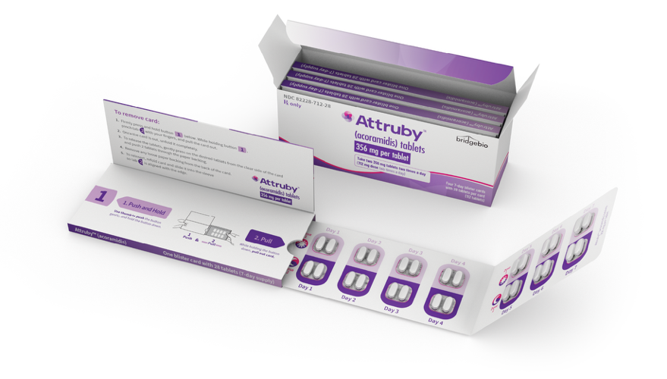
Figure 2-1: Attruby Package [https://attrubyhcp.com/wp-content/themes/ATTRuby_day30/assets/img/convenient-dosing/open_box_preview2.webp]
Attruby has no contraindications. [Attruby PI p2/B]

Section 2.2: Adverse Reactions and Drug Interactions
The safety information for Attruby is derived from the clinical trial data and includes all patients who were randomized and received at least 1 dose of acoramidis or placebo. [Attruby PI p2/A] Note that the efficacy analysis was based on the modified intent-to-treat (mITT) population, which included all patients who were randomized and received at least 1 dose of acoramidis or placebo and excluded patients (n=21) with estimated glomerular filtration rate (eGFR) <30. [Gillmore 2024 p135/A, B]
Trial design: [Attruby PI p2/A]
- Randomized, double-blind, and placebo-controlled
- Set treatment duration of 30 months
- Total randomized participants: 632 [Gillmore 2024 p135/B]
- Intent-to-treat (ITT) population: 421 patients in the Attruby treatment arm and 211 in the placebo arm
- mITT: 409 patients in the Attruby treatment arm and 202 in the placebo arm
- Participants received Attruby 712 mg twice daily by mouth
- Median duration was 29 months

Adverse Reactions
Participants treated with Attruby experienced more frequent gastrointestinal issues (eg, diarrhea and upper abdominal pain) compared to those given placebo: [Attruby PI p2/A]
- Diarrhea: 11.6% with Attruby; 7.6% with placebo
- Upper abdominal pain: 5.5% with Attruby; 1.4% with placebo
About the same proportion of participants in both groups stopped the study drug due to side effects: 9.3% for Attruby and 8.5% for placebo. [Attruby PI p2/A]

Laboratory Tests
When starting Attruby, serum creatinine levels rise and eGFR levels decline within 4 weeks, then levels stabilize. [Attruby PI p2/G]
- In a study in adults with ATTR-CM, those taking Attruby had an average increase in serum creatinine of 0.2 mg/dL compared to no change (0.0 mg/dL) with placebo.
- The eGFR in study participants taking Attruby declined by 8.2 mL/min/1.73 m² on average, while the placebo group experienced a decrease of 0.7 mL/min/1.73 m² at Week 4.
On Attruby treatment discontinuation, changes in both eGFR and serum creatinine were reversible. [Attruby PI p2/G] There are no monitoring requirements for Attruby in the prescribing information.

Drug Interactions
Because acoramidis is metabolized via UDP-glucuronosyltransferase (UGT) enzyme-mediated glucuronidation, Attruby should not be co-administered with UGT inducers or strong cytochrome P450 3A (CYP3A) inducers due to the risk of potentially reduced acoramidis exposure. [Attruby PI p3/A] Some examples of CYP3A inducers include carbamazepine, rifampin/rifabutin, and St. John’s Wort. [Wright 2019 p23/A,B] [Kanefendt 2023 p1026/A, p1028/A,B]
Acoramidis is an inhibitor of cytochrome P450 2C9 (CYP2C9). [Attruby PI p3/B] When substrates of CYP2C9 are co-administered with acoramidis, a rise in CYP2C9 substrate concentrations may occur. Therefore, when Attruby is co-administered with sensitive CYP2C9 substrates, clinicians are advised to consider monitoring patients more frequently for signs of exposure-related toxicity. [Attruby PI p3/B]

Section 2.3: Use in Specific Populations
To learn about the use of Attruby in specific populations, click on each topic below.
Interactivity: Tabs
Tab 1: Pregnancy
There are insufficient data on acoramidis use during pregnancy to determine if it causes birth defects, miscarriage, or other pregnancy-related issues. In animal studies with rats and rabbits, no abnormalities were observed at very high doses. The risk of birth defects and miscarriage for the target population is unknown, but generally, 2% to 4% of pregnancies in the US have major birth defects and 15% to 20% end in miscarriage. [Attruby PI p3/C]

Tab 2: Lactation
There are no data on whether acoramidis is present in human or animal milk or its impact on breastfed infants or milk production. When deciding to breastfeed, weigh the benefits for the infant against the mother's need for Attruby and any potential risks to the infant from the drug or the mother's condition. [Attruby PI p4/B]

Tab 3: Pediatric use
Attruby has not been studied in pediatric populations. [Attruby PI p4/C]

Tab 4: Geriatric use
Elderly patients (65 and older) do not need a dosage adjustment. In the clinical study of 632 participants, nearly all (97%) were aged 65 years or older, with a median age of 78. [Attruby PI p4/D]


Section 2.4: How Supplied, Storage and Handling, and Patient Support Program

How Supplied
Attruby tablets are available in a convenient 1-month (28-day) supply. [Attruby PI p9/A]
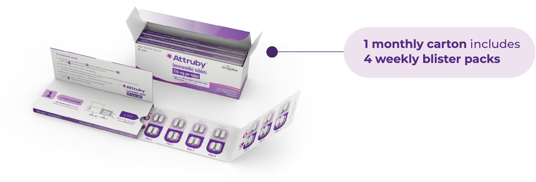

Storage and Handling
Attruby should be stored in its original blister card until ready to use at a controlled room temperature of 20°C to 25°C (68°F to 77°F); brief exposures to temperatures between 15°C and 30°C (59°F to 86°F) are allowed. [Attruby PI p10/A]

ForgingBridges®
ForgingBridges is committed to providing continuous support. [HCP Attruby iCVA 2.0 Final p55/A]
ForgingBridges is a personalized support program, providing healthcare professionals (HCPs) and their patients with: [HCP Attruby iCVA 2.0 Final p55/A]
- Dedicated team to support physicians, office staff, and patients throughout the treatment journey [HCP Attruby iCVA 2.0 Final p55/B]
- Field Reimbursement Managers (FRMs) for HCPs and office staff
- Patient Access Liaisons (PALs) for patients and their caregivers
- ForgingBridges Specialists for personalized coverage support and financial assistance options
- Insurance navigation [HCP Attruby iCVA 2.0 Final p55/C]
- ForgingBridges Copay Assistance [HCP Attruby iCVA 2.0 Final p55/D]
- Commercially insured patients only. Additional terms and conditions may apply.
- ForgingBridges free trial [HCP Attruby iCVA 2.0 Final p55/E]
- New Attruby patients with any insurance coverage are eligible.
- ForgingBridges Patient Assistance [HCP Attruby iCVA 2.0 Final p55/F]
- Patients must meet certain income criteria and be currently uninsured, have limited coverage, or have received an appeal denial.
- ForgingBridges QuickStart [HCP Attruby iCVA 2.0 Final p55/G]

Once prescribed Attruby, patients or their caregivers can connect with ForgingBridges Specialists who can screen their eligibility for financial assistance programs.
Additional information on the services offered by ForgingBridges is available at ForgingBridges.com.

Key Concepts
Interactivity: Accordion
Accordion 1: Attruby Dosage, Administration, and Contraindications
The recommended dosage is 712 mg (two 356 mg tablets) taken orally twice a day, with or without food. [Attruby PI p2/D,E]
Tablets should be swallowed whole; do not cut, crush, or chew. [Attruby PI p2/D]
Attruby has no contraindications. [Attruby PI p2/B]
Accordion 2: Adverse Reactions and Drug Interactions
Safety data are derived from clinical trial data including all patients randomized and receiving at least 1 dose of acoramidis or placebo. [Attruby PI p2/A]
Efficacy analysis was based on mITT population, excluding patients (n=21) with eGFR <30. [Gillmore 2024 p135/A, B]
The trial was randomized, double-blind, placebo-controlled with a 30-month duration. The median duration was 29 months. [Attruby PI p2/A]
Adverse reactions included more frequent gastrointestinal issues (diarrhea and upper abdominal pain) with Attruby versus placebo. [Attruby PI p2/A]
Similar discontinuation rates due to side effects occurred in both treatment groups: 9.3% (Attruby) versus 8.5% (placebo). [Attruby PI p2/A]
Serum creatinine increases and eGFR decreases were observed within 4 weeks of starting Attruby and then stabilized thereafter. [Attruby PI p2/G] Changes are reversible upon discontinuation. [Attruby PI p2/G]
Acoramidis is metabolized via UGT enzyme-mediated glucuronidation; avoid co-administration with UGT inducers or strong CYP3A inducers due to reduced exposure risk. [Attruby PI p3/A][Wright 2019 p23/A,B]
Acoramidis inhibits CYP2C9; co-administration with CYP2C9 substrates may increase substrate concentrations. [Attruby PI p3/B]
Accordion 3: Use in Specific Populations
Insufficient data are available on acoramidis use in pregnancy; animal studies show no abnormalities at high doses. [Attruby PI p3/C]
There are no data on presence of acoramidis in milk or effects on infants; weigh benefits and risks when deciding to breastfeed. [Attruby PI p4/B]
Attruby has not been studied in pediatric populations. [Attruby PI p4/C]
No dosage adjustment is needed for patients 65 years and older. [Attruby PI p4/D]
Accordion 4: How Supplied, Storage and Handling, and ForgingBridges
Attruby tablets are available in a blister pack as a 28-day supply. [Attruby PI p2/B]
Store ATTRUBY at controlled room temperature 20°C to 25°C (68°F to 77°F); excursions permitted to15°C to 30°C (59°F to 86°F). Store in original blister card until ready to use. [Attruby PI p10/A]
ForgingBridges is a personalized support program for HCPs and patients that provides: [CVA p23/A, B, C]
  - FRMs to support HCPs and office staff through the treatment journey
  - PALs to support patients and their caregivers through the treatment journey

Check Your Progress
- The recommended dosage of Attruby is _____ orally twice daily (with or without food).
- 412 mg
- 512 mg
- 612 mg
- 712 mg
- There are no contraindications to Attruby.
- True
- False
- In the clinical trial evaluating Attruby for transthyretin amyloidosis cardiomyopathy (ATTR-CM), participants treated with Attruby had a higher frequency of which of the following adverse reactions compared to placebo? Select all that apply.
- Joint pain
- Diarrhea
- Upper abdominal pain
- Headache
- Acoramidis is metabolized by which of the following?
- Cytochrome P450 2C9 (CYP2C9)
- CYP3A
- UDP-glucuronosyltransferase (UGT) enzyme-mediated glucuronidation
- Glycogenolysis
- Which of the following statements about use of Attruby in specific populations are true? Select all that apply.
- The safety and effectiveness of Attruby have not been established in pediatric patients.
- Attruby is not recommended in patients with mild liver disease.
- There are no data on whether acoramidis is present in human or animal milk or its impact on breastfed infants or milk production.
- No dosage adjustment is required for elderly patients (≥65 years).
- Attruby tablets are available as a blister pack as a __________ supply.
- 7-day
- 28-day
- 90-day
- 6-month
- Attruby should be stored __________.
- at room temperature
- in the refrigerator
- in the freezer
- away from sunlight

Answers
- D [Attruby PI p2/D]
- True [Attruby PI p2/B]
- B, C [Attruby PI p2/A]
- C [Attruby PI p3/A]
- A, C, D [Attruby PI p3/C, p4/B, C, D]
- B [Attruby PI p2/B]
- A [Attruby PI p10/A]

Chapter 3: Clinical Pharmacology, Nonclinical Toxicology, and Clinical Efficacy

Learning Objectives
Interactivity: Accordion
Upon completion of this chapter, learners will be able to:
Describe the mechanism of action of acoramidis
List key clinical pharmacologic attributes of acoramidis
Describe the nonclinical toxicology of acoramidis
Explain the design and patient population of the ATTRibute-CM study
Describe the key efficacy findings and impact on biomarkers for ATTRibute-CM

Section 3.1: Attruby Mechanism of Action

TTR Stabilization
Attruby is a TTR stabilizer. [Attruby PI p5/A][Judge 2019 p289/A,B] Acoramidis was designed to mimic the properties of the T119M variant of the TTR protein, helping to stabilize the TTR tetramer; in vitro studies have shown that acoramidis achieves greater than 90% TTR protein tetramer stabilization. [Attruby PI p5/A][Judge 2019 p287/A, p289/A, p290/A,B]
Interactivity: Callout
Hit the Ground Running
Attruby has a number of key characteristics:
Designed to mimic the properties of the T119M variant, a naturally occurring stabilizing variant of TTR that has been associated with reduced disease severity [Sanguinetti 2022 p7/A][Judge 2019 p287/A]
Stabilizes TTR with enthalpically-driven binding at 2 individual sites in the T4 pocket [Attruby PI p5/B][Miller 2018 p4/A,B, p5/A, p6/A]
Is the only FDA-approved treatment described as achieving “near-complete” in vitro TTR stabilization in its label [Attruby PI p5/A][Judge 2019 p287/A, p289/A,B]

Interactivity: Callout
⊕ ZOOM IN: T119M Variant
The T119M mutation has a stabilizing effect on the TTR tetramer, protecting against dissociation. [Sanguinetti 2022 p7/A][Sant’Anna 2017 p3/A][Hammarström 2002 p16428 Figure 1/A]
The T119M mutation appears to delay symptom onset and reduce the symptoms of ATTR in people who inherit a disease-causing TTR mutation along with a normal TTR gene. [Sant’Anna 2017 p2/A,B]

Section 3.2: Key Clinical Pharmacology Attributes
Learn about the pharmacodynamics of Attruby by clicking on each of the following topics.
Interactivity: Accordion
Accordion 1: TTR Stabilization
Levels of sTTR or in vitro TTR stabilization assays were used as a marker of TTR stabilization. [Attruby PI p5/A] In ATTRibute-CM, the pivotal clinical trial for Attruby in ATTR-CM, increases from baseline in sTTR (also known as prealbumin) level were observed in patients with ATTR-CM treated with Attruby by Day 28 (Figure 3-1). [Gillmore 2024 p133/A, p134/D, p139 Figure 3/D][Judge 2019 p288/A, p289/A, p290/A,B][Attruby PI p5/A]
A secondary endpoint post-hoc analysis was performed using data from 557 participants (among the 632 participants in the ITT population) who had sTTR data available at baseline and at Day 28 (the first time point measured in ATTRibute-CM), and whose TTR variant status (TTRwt or TTRv) was known. [Maurer 2025 p1913/A] Results showed patients with ATTRv-CM had lower baseline levels and experienced greater early (Day 28) increases of sTTR than those with ATTRwt-CM. [Maurer 2025 p1914/A][Gillmore 2024 supplement p3/A. 4/A] However, both groups treated with Attruby saw early (Day 28) increases in sTTR. [Maurer 2025 p1914/A]
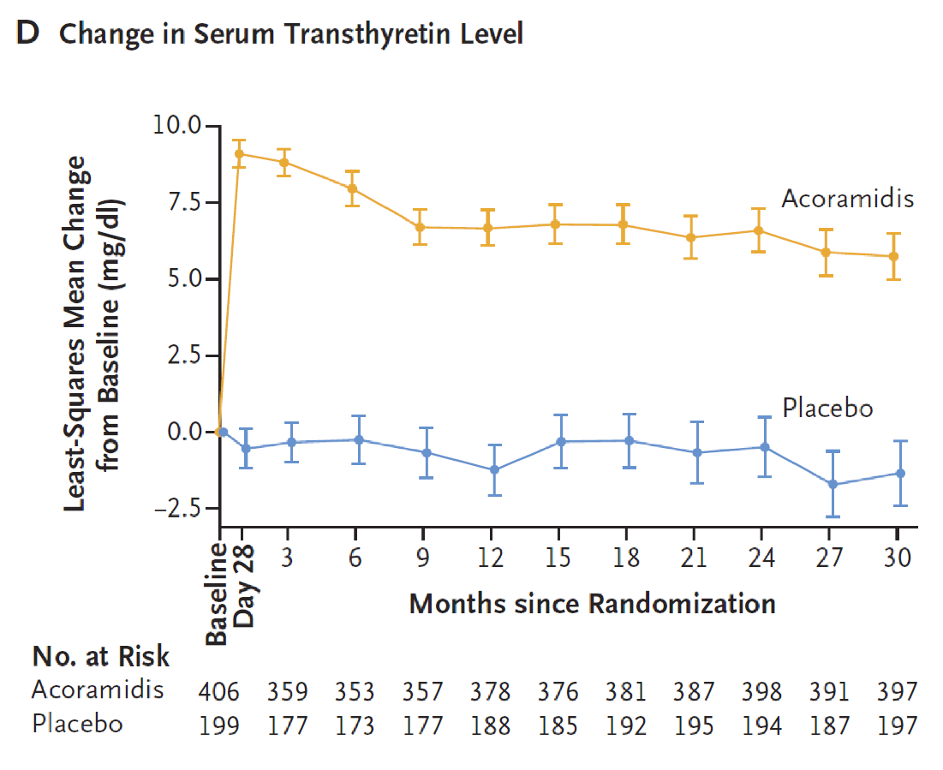
Figure 3-1: Change From Baseline in Serum TTR Level in ATTRibute-CM [Gillmore 2024 p133/A,B]
Accordion 2: Free Thyroxine
Attruby may lower free thyroxine levels in the blood without affecting thyroid stimulating hormone (TSH). The decrease in free thyroxine is likely because TTR stabilizers, such as Attruby, reduce thyroxine binding to TTR or displace it from TTR. [Attruby PI p5/C]
Accordion 3: NT-proBNP
Some evidence suggests that NT-proBNP levels are inversely correlated with survival and disease burden in ATTR-CM (ie, lower NT-proBNP levels are associated with longer survival and lower disease burden). [Kittleson 2023 p1110/A, C, D, p1112 Table 12/A] In the pivotal trial of Attruby in patients with ATTR-CM, Attruby treatment was associated with smaller increases (approximately 50% less) in NT-proBNP at Month 30 than placebo (Figure 3-2). [Attruby PI p5/D]
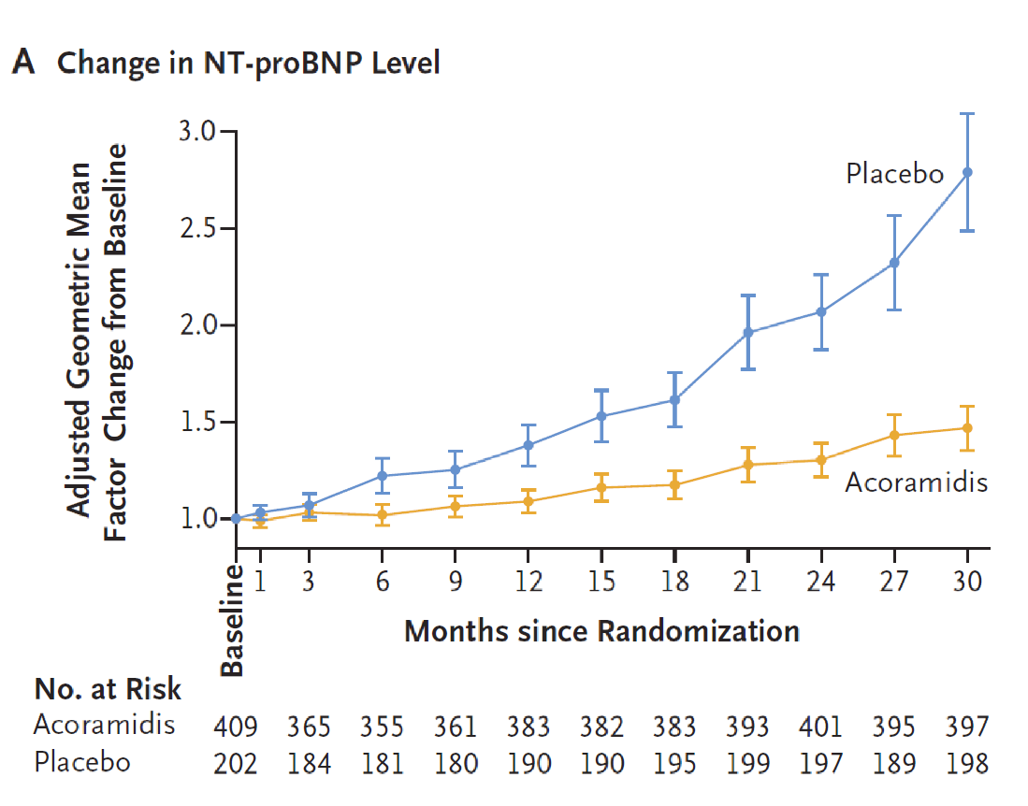
Figure 3-2: Change in NT-proBNP Level in ATTRibute-CM [Gillmore 2024 p139 Figure 3/A]
Accordion 4: Troponin I
The increase in troponin I levels was lower with Attruby compared to placebo. [Attruby PI p5/D] Troponin levels are generally higher in ATTR-CM and can indicate more severe disease. [Kittleson 2023 p1095/D, p1110/A] Troponin levels are 1 component of certain staging systems for ATTR-CM. [Kittleson 2023 p1083/B, p1110/A,C, p1112 Table 12]
Accordion 5: Cardiac Electrophysiology
Attruby has no clinically relevant effect on the QTc interval. [Attruby PI p5/E]

Interactivity: Callout
⊕ ZOOM IN: Biomarkers in ATTR-CM
A reduction in NT-proBNP level is desirable because elevated levels are associated with greater heart stress. [Kittleson 2023 p1110/A, C, D, p1112 Table 12/A]
A reduction in troponin is desirable because elevated levels of troponin are associated with more severe disease. [Kittleson 2023 p1095/D, p1110/A][Kittleson 2023 p1083/B, p1110/A,C, p1112 Table 12]
Increases in sTTR (also known as prealbumin) are desirable because higher sTTR levels are associated with greater tetramer stability. [Maurer 2025 p1912/A, p1914/A]
sTTR or prealbumin is an emerging biomarker that is specific for ATTR-CM, whereas NT-proBNP and troponin are general cardiac biomarkers and are not specific to ATTR-CM. [Kittleson 2023 p1110/A, C, D, p1112 Table 12/A]

Click on each topic to learn about the pharmacokinetics of Attruby.
Interactivity: Vertical Tabs
Tab 1: Steady-State
Steady-state of acoramidis is reached after approximately 4 days of administration at the recommended dosage of 712 mg twice daily. [Attruby PI p5/F]
Tab 2: Effect of Food
Food has no effect on the pharmacokinetics of acoramidis. [Attruby PI p5/H]
Tab 3: Elimination
Acoramidis has an effective half-life of approximately 6 hours. [Attruby PI p6/A]
Tab 4: Specific Populations
The pharmacokinetics of acoramidis do not vary significantly based on: [Attruby PI p6/B]
  - Age
  - Race/ethnicity (including Japanese and non-Japanese)
  - Sex
  - Kidney function
How an impaired liver affects the pharmacokinetics of acoramidis is unknown
Tab 5: Drug Interaction Studies
As noted in Chapter 2, acoramidis is metabolized via UGT enzyme-mediated glucuronidation and therefore, Attruby should not be used concomitantly with UGT inducers or strong CYP3A inducers due to the risk of potentially reduced acoramidis exposure. In addition, acoramidis is a CYP2C9 inhibitor. When Attruby is co-administered with sensitive CYP2C9 substrates, clinicians are advised to consider monitoring patients more frequently for signs of exposure-related toxicity. [Attruby PI p6/C]

Interactivity: Callout
⊕ ZOOM IN: Half-Life
Elimination half-life measures how long it takes for a drug's concentration in the body to decrease by half, helping determine dosing intervals and steady-state levels. [Hallare 2025 p1/A] Terminal half-life is the time required for a drug’s plasma concentration to fall by 50% during the final, slowest elimination phase of a multi‑compartment pharmacokinetic profile. [Andrade 2022 p e2/A] The terminal half-life is the value clinicians most often consider when making decisions about drug dosing and is the half-life value most often included in the prescribing information. [Momper 2025 p169/A] However, the terminal half-life may only reflect a small portion of the concentration-time curve and may not reflect actual drug accumulation after multiple dosing. [Momper 2025 p169/B] The effective half-life is a half-life value that may be more appropriate for drugs with formulations that exhibit complex drug release and absorption because it considers both single and multiple doses and uses the accumulation ratio to better reflect drug buildup and duration in the body. [Momper 2025 p169/C, p170/A]

Nonclinical Toxicology
Animal studies showed no evidence of carcinogenicity with acoramidis. [Attruby PI p6/D] Assays and in vivo tests found no evidence of mutagenicity or clastogenicity for acoramidis. [Attruby PI p7/F] Animal studies showed no effects on fertility, reproductive performance or mating behavior of acoramidis on rats. [Attruby PI p7/G]

Section 3.2: ATTRibute-CM Design and Patient Population
The ATTRibute-CM study evaluated the impact of Attruby on mortality, hospitalization, and quality of life (defined as health-related quality of life and functional capacity over 30 months). [Attruby PI p7/A,D, E] This trial was a prospective, multicenter, international, randomized (2:1), double-blind, placebo-controlled study in 611 adult patients with wild-type or variant ATTR-CM. [Attruby PI p7/A]A 12-month open-label extension trial was open to participants who completed treatment in the 30-month ATTRibute-CM study. [Judge 2024 p603/A]Use of tafamidis was not allowed in the open-label extension; participants on tafamidis at the end of the 30-month treatment period in ATTRibute-CM who opted to enroll in the open-label extension were required to discontinue tafamidis.
The efficacy analysis was based on the mITT population. The mITT population (n=611) included all patients who were randomized and received at least 1 dose of acoramidis or placebo and excluded patients (n=21) with eGFR <30 mL/min/1.73 m². [Gillmore 2024 p135/A, B]

Study Design
Interactivity: Horizontal Tabs
Tab 1: Key Inclusion Criteria [Gillmore 2024 p134/A]
Adults with diagnosed ATTR-CM (wild-type or variant)
History of heart failure
New York Heart Association (NYHA) Class I-III [Gillmore 2024 supplemental_protocol p8/A]
ATTR-positive biopsy or scintigraphy (sometimes using the radiotracer technetium-99m, abbreviated as 99mTc-scan)
AL or “light chain” amyloidosis excluded if diagnosis by scintigraphy
Tab 2: Key Exclusion Criteria [Gillmore 2024 p134/B]
AL amyloidosis
eGFR <15 mL/min/1.73 m²
Tab 3: Concomitant medications
Concomitant use of tafamidis was allowed after 12 months (22.8% placebo versus 14.9% Attruby patients; mean duration ~11 months) [Gillmore 2024 p134/E, p140/A]
Tab 4: Primary Endpoint [Attruby PI 2024 p7/D][Gillmore 2024 p134/C, p135/A]
The primary endpoint was a hierarchical composite of the following, analyzed hierarchically using the stratified Finkelstein-Schoenfeld (F-S) test:
  - All-cause mortality (ACM)
  - Cumulative frequency of CVH over 30 months
  - Change from baseline in NT-proBNP
  - Change from baseline in 6-minute walk distance (6MWD) on the 6-minute walk test (6MWT)
The Attruby prescribing information has the 2-component endpoint of ACM and cumulative frequency of CVH as the primary endpoint. [Attruby PI 2024 p7/D]
Tab 5: Secondary Endpoints
Secondary endpoints included: [Gillmore 2024 p134/D][Gillmore 2024 supplemental_protocol p20/A, p21/A]
  - Change from baseline in 6MWD
  - Change from baseline in Kansas City Cardiomyopathy Questionnaire-Overall Summary (KCCQ-OS)
  - Change from baseline in sTTR
  - ACM
  - Safety assessments
Additional secondary endpoints that were prespecified but non-alpha protected: [Gillmore 2024 supplemental protocol p45/A, 46/A]
  - Cardiovascular mortality
  - Cumulative frequency of CVH
  - Change from baseline in NT-proBNP
Participants were randomly assigned in a 2:1 ratio to receive either 712 mg of Attruby (409 participants) or a placebo (202 participants) twice daily for 30 months. [Gillmore 2024 p135/B, C] [Attruby PI p7/B] The treatment groups were stratified based on the type of ATTR-CM (wild-type or variant), NT-proBNP level, and eGFR. [Attruby PI p7/B] There were no significant differences in baseline characteristics between the treatment groups. [Attruby PI p7/C]
The design and patient disposition of the trial are summarized in Figure 3-3.

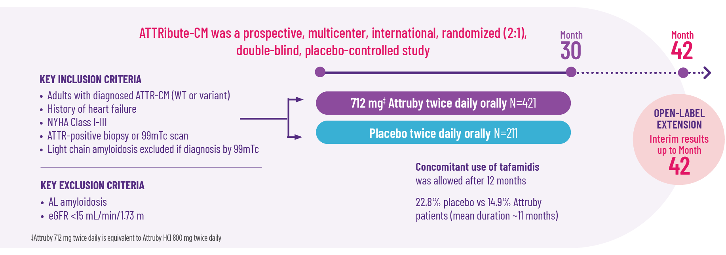
Figure 3-3: Design and Patient Disposition in ATTRibute-CM [Source: HCO Attruby] [HCP Attruby iCVA v2.0 FINAL p24]

Patient Demographics and Baseline Characteristics
The mITT population characteristics are shown in Table 3-1. Note that the proportion of patients in earlier stages of disease reflects recent changes in disease recognition and management. [Ioannou 2022 p1658/A,B, p1661/A]
The average age of the participants was 77 years, most were male (90.8%) and White (87.9%), with 4.7% Black or African American, 2.1% Asian, and 5.3% identifying as other races. A total of 19% of participants had a history of permanent pacemaker implantation and 58% had a history of atrial fibrillation. [Attruby PI p7/C]
Table 3-1: Patient Demographics and Baseline Characteristics in ATTRibute-CM
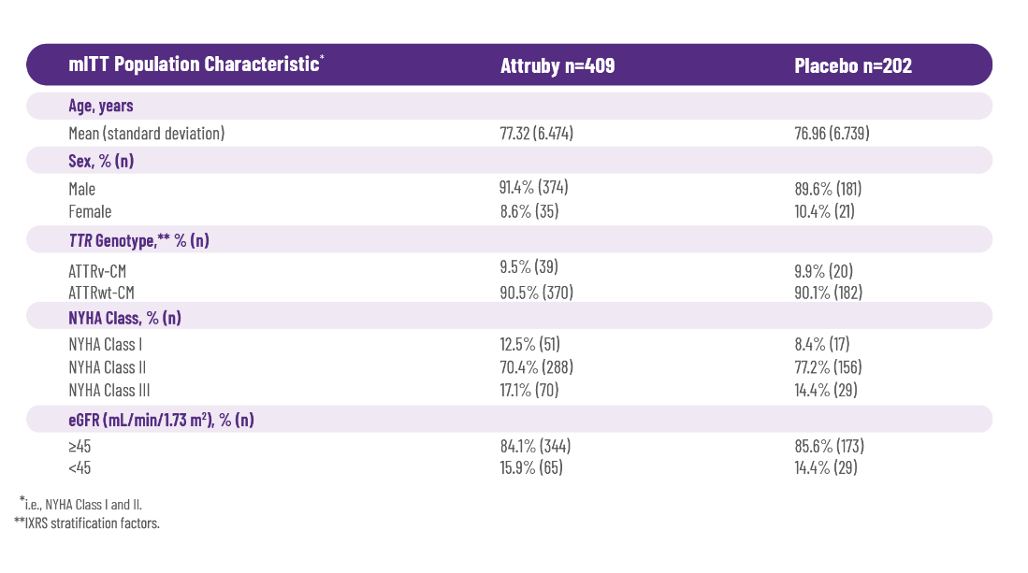

Section 3.3: ATTRibute-CM Efficacy Results

Primary Composite Endpoint
Attruby significantly reduced the combination of all-cause mortality (ACM) and cardiovascular-related hospitalization (CVH) at Month 30 (P=0.018, assessed using the stratified F-S test). [Attruby PI p7/D]
ACM was reported in 19% and 26% of participants in the Attruby and placebo groups, respectively. [Attruby PI p7/D] Attruby provided an early and lasting treatment benefit (Figure 3-4).
A Cox regression analysis indicated a 35.5% decrease in the risk of the composite of ACM or first CVH (hazard ratio: 0.645; 95% confidence interval [CI]: 0.500, 0.832). [Attruby PI p8/B] As shown in Figure 3-4, the time-to-first-event Kaplan-Meier curves began separating at 3 months and diverged through 30 months. [Attruby PI p8 Figure 3/A]
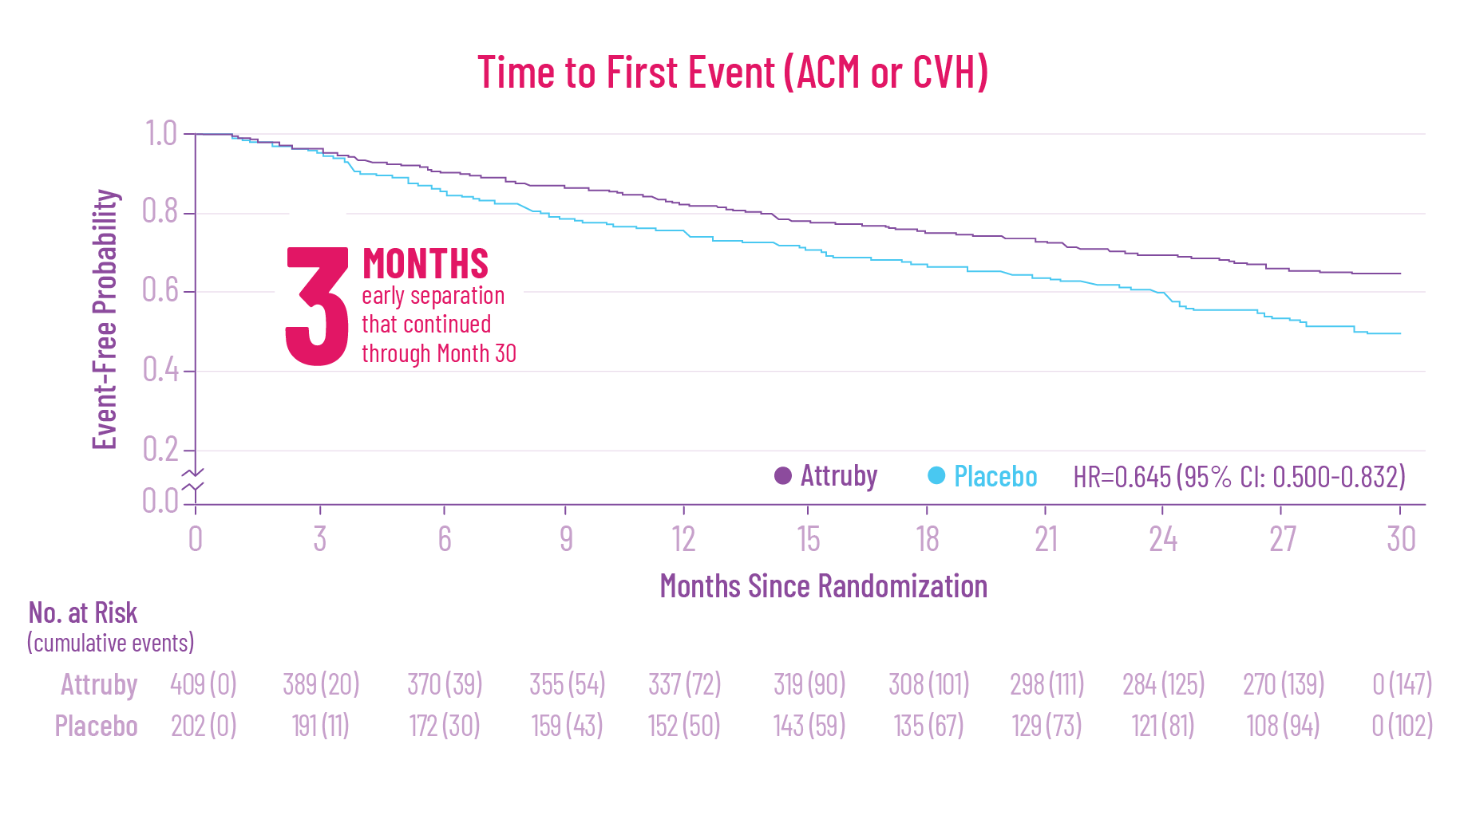
Figure 3-4: Time to First Event (ACM or CVH) [Attruby PI p8 Figure 3/A][HCP Attruby iCVA v2.0 FINAL p33]

Post-Hoc Analysis
Further, in a post-hoc analysis of ATTRibute-CM, there was a 42% relative risk reduction (RRR) in the composite of ACM and recurrent CVH. [Judge 2025 p1008/A, Central Illustration/B]
An exploratory prespecified subgroup analysis showed consistent reduction in risk of ACM or first CVH across both ATTRwt-CM and ATTRv-CM patients (Figure 3-5). [Davis 2025 poster Results col3 para2/A] [HCP Attruby iCVA v2.0 FINAL p34] Subgroup analyses were descriptive and exploratory in nature. Results are limited by small sample size.

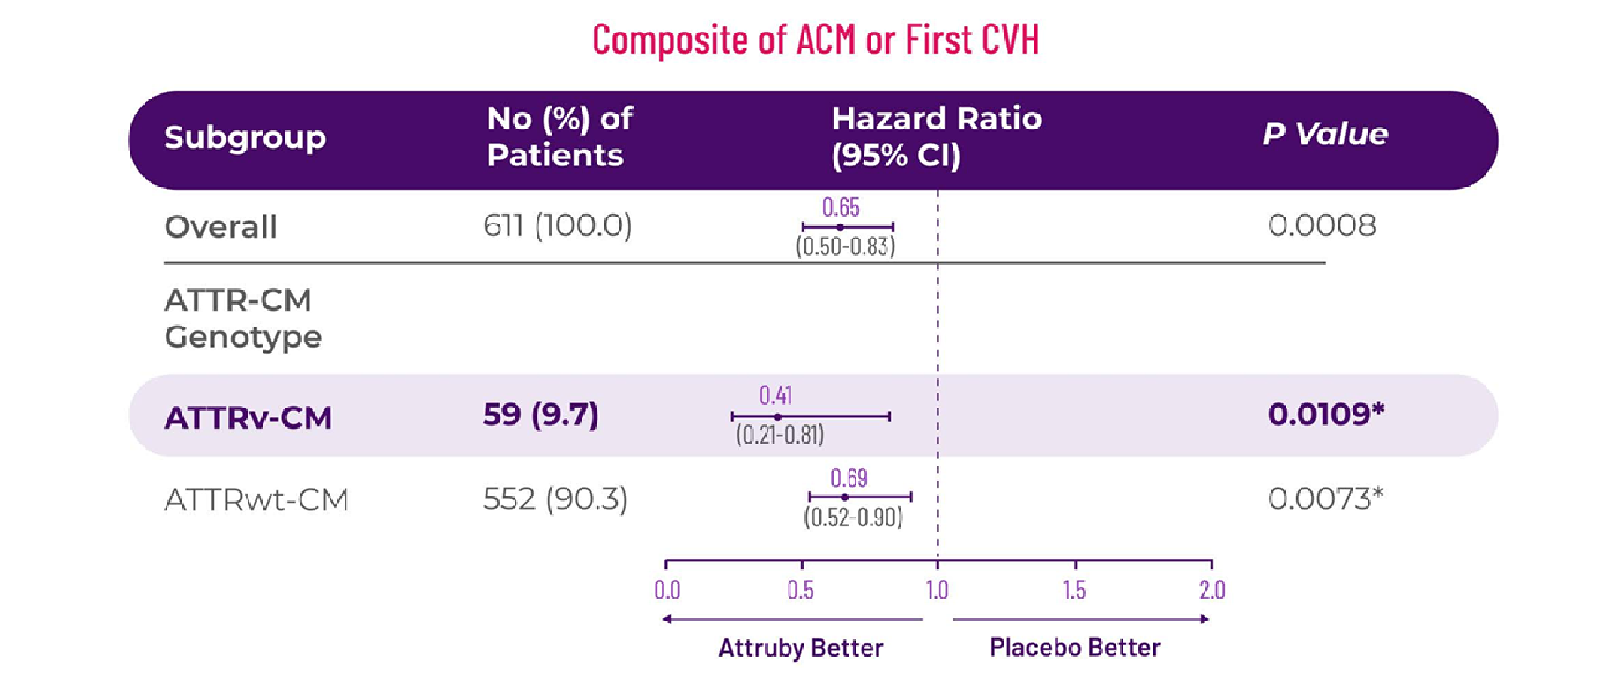
Figure 3-5: Hazard Ratio of ACM or First CVH by ATTR-CM Genotype; mITT population (N=611) [Davis 2025 poster Results col 3 Figure 2][Attruby iCVA v2.0 FINAL p34]
In patients with ATTRv-CM (n=59), there was a 59% RRR in ACM or first CVH observed with Attruby (n=39) versus placebo (n=20). [Davis 2025 poster Results col 3 Figure 2, col 2 Table, Row 2]
Remember when going over content in approved sources with customers, you must always include the approved standard of limitations statement. Exploratory analyses are hypothesis-generating, not powered to generate conclusive results, and may not reflect the broader patient population.

Secondary Endpoints
Attruby efficacy across secondary endpoints is discussed below. [Gillmore 2024 p138/A,B]
Note that in discussions with HCPs about Attruby clinical trial data, you must first introduce the ATTRibute-CM primary endpoint before presenting post-hoc and subgroup analyses. Subgroup analyses are based on small patient numbers and must always be clearly delineated from the primary endpoint analyses. This information on both post-hoc and subgroup analyses must be called out during a detail.

ACM
At 30 months, 81% of patients treated with Attruby remained alive versus 74% of patients taking placebo. [Gillmore 2024 p139 Fig 3/E] Most (79%) of the deaths that occurred were due to cardiovascular causes (Figure 3-6). [Attruby PI p7/D]
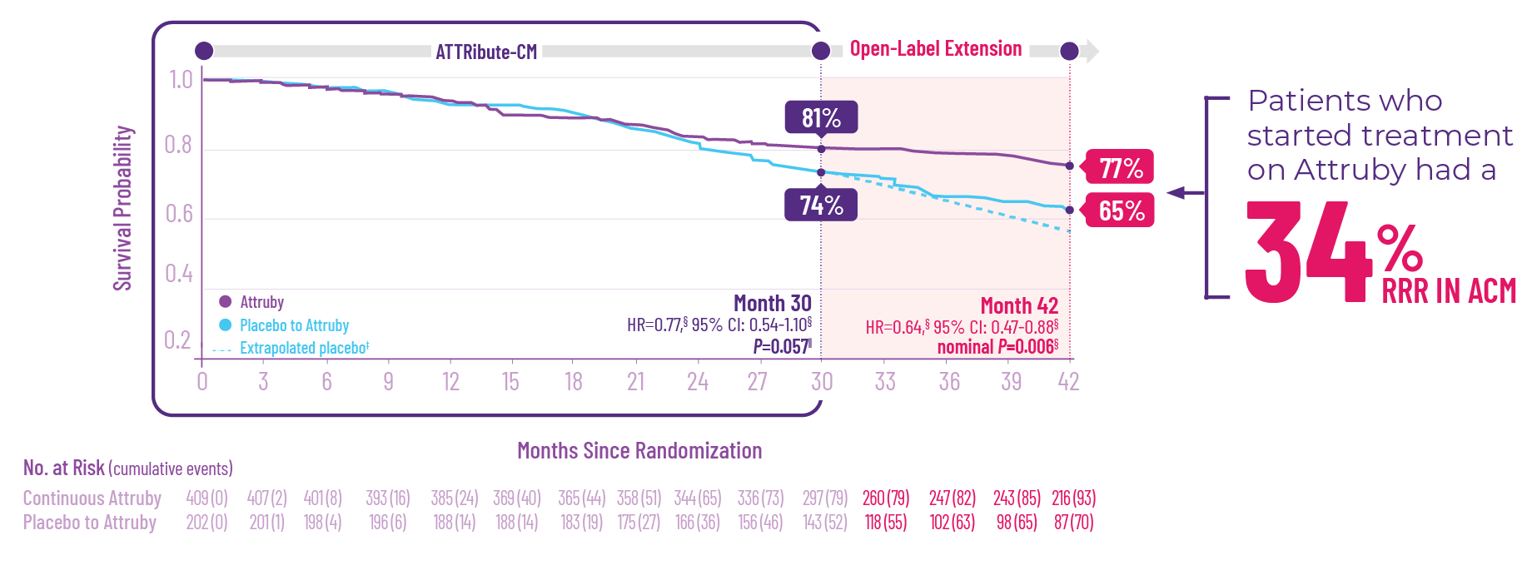
† Data are for the full analysis set, which included the mITT population in ATTRibute-CM defined as all participants who were randomized to Attruby or placebo, received ≥1 dose of Attruby or placebo, had ≥1 efficacy evaluation after baseline, and had baseline eGFR of ≥30 mL/min/1.73 m2. Data were analyzed using a stratified Cox proportional hazards model.
‡ Expected results if participants had continued receiving placebo in the OLE study. Survival probabilities beyond Month 30, assuming no open-label Attruby had been taken, were extrapolated based on a Weibull probability model for the time to the ACM event estimated from the data observed in the ATTRibute-CM study.
§ Assessed by the Cox proportional hazards model.
§ Assessed by the Cochran-Mantel-Haenszel test.
Note that the ACM analysis was not statistically significant by either the Cox regression analysis or prespecified sensitivity analysis. [Gillmore p140/C]

Figure 3-6: Key Secondary Endpoint: ACM † [Gillmore p139 Fig 3E][HCP Attruby iCVA 2.0 FINAL p37] p15/B]

CVH Frequency
Attruby reduced the frequency of CVH by half. [Gillmore 2024 p137/A] The mean number of CVH events was 0.3 per year for Attruby-treated patients compared to 0.6 per year for placebo. [Attruby Pi p7/D]

CVH by Subgroup
Results from a prespecified subgroup analysis showed that Attruby delivered reduction in frequency of CVH in both ATTRwt-CM and ATTRv-CM. [Gillmore 2024 Appendix figure S4/A] As shown in Figure 3-7, in patients with ATTRv-CM, there was a 62% RRR in CVH frequency with Attruby versus placebo. This analysis was descriptive and exploratory in nature. Results are limited by small sample size.
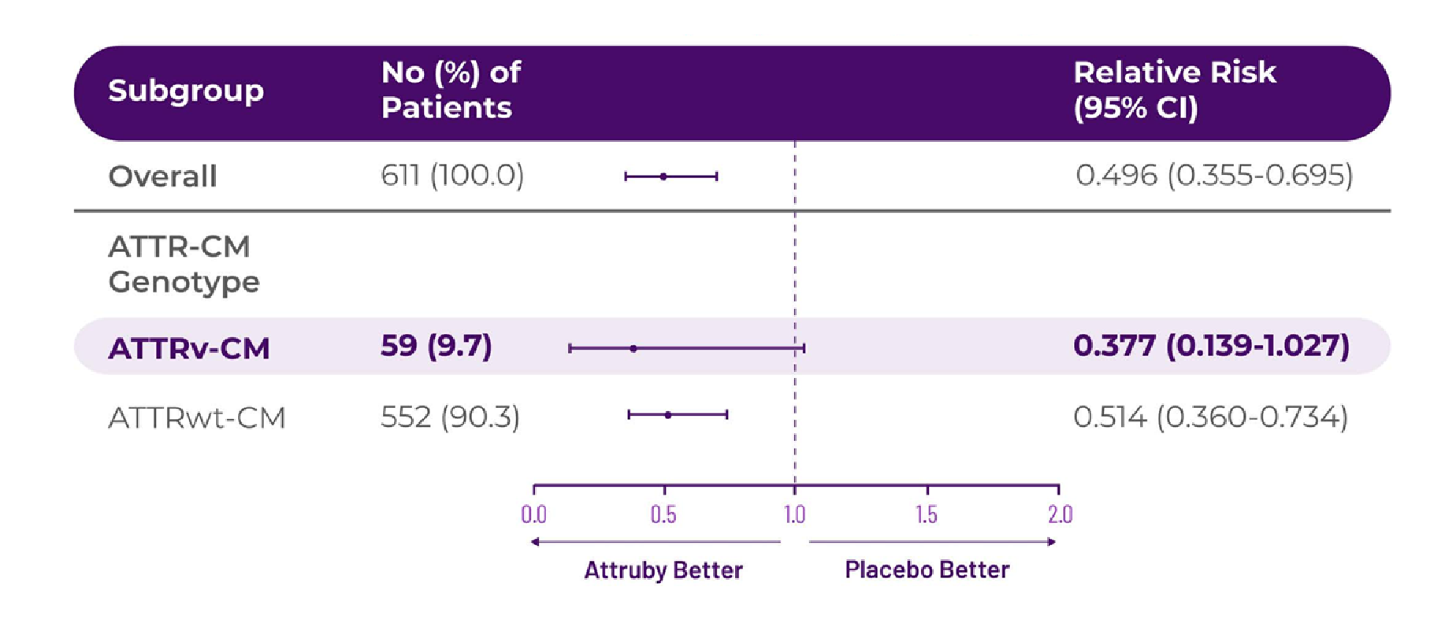
Figure 3-7: Relative Risk in Frequency of CVH by ATTR-CM Genotype Subgroup in ATTRibute-CM [Gillmore 2024 Appendix Figure S4/A][HCP Attruby iCVA 2.0 Final p40]

Quality of Life
Attruby made a difference in health-related quality of life compared to placebo. [Attruby Pi p7/E][Gillmore 2024 p138A,B] As shown in Figure 3-8, Attruby achieved statistically significant results in health-related quality of life as measured by the KCCQ-OS at Month 30 (P<0.0001). [Attruby Pi p7/E][Gillmore 2024 p138/B]

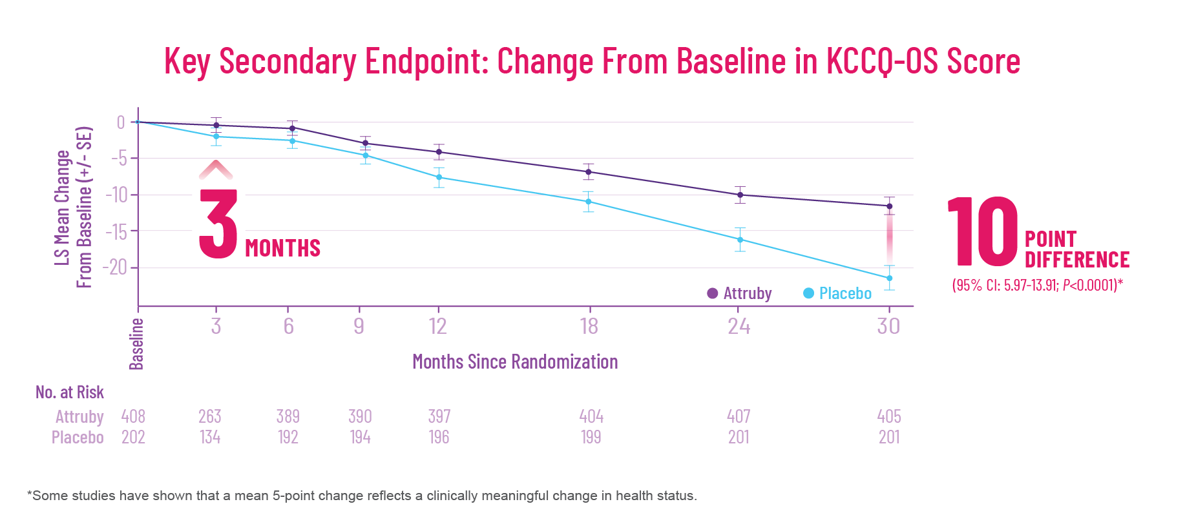

Figure 3-8: Key Secondary Endpoint: Change From Baseline in KCCQ-OS Score [Attruby PI p8 Figure 2][HCP Attruby iCVA 2.0 Final p42]
Patients in the Attruby treatment group had better scores on the KCCQ-OS, with a difference of 10 points (95% CI: 5.97 to13.91; P<0.0001). [Gillmore 2024 p138/B] Some evidence suggests that a mean 5-point change in the KCCQ score reflects a clinically meaningful change in health status. [Spertus 2020 p2382/A, p2384/A]
KCCQ in the Variant Subgroup
Attruby also made a difference in health-related quality of life compared to placebo in the variant population (Figure 3-9).
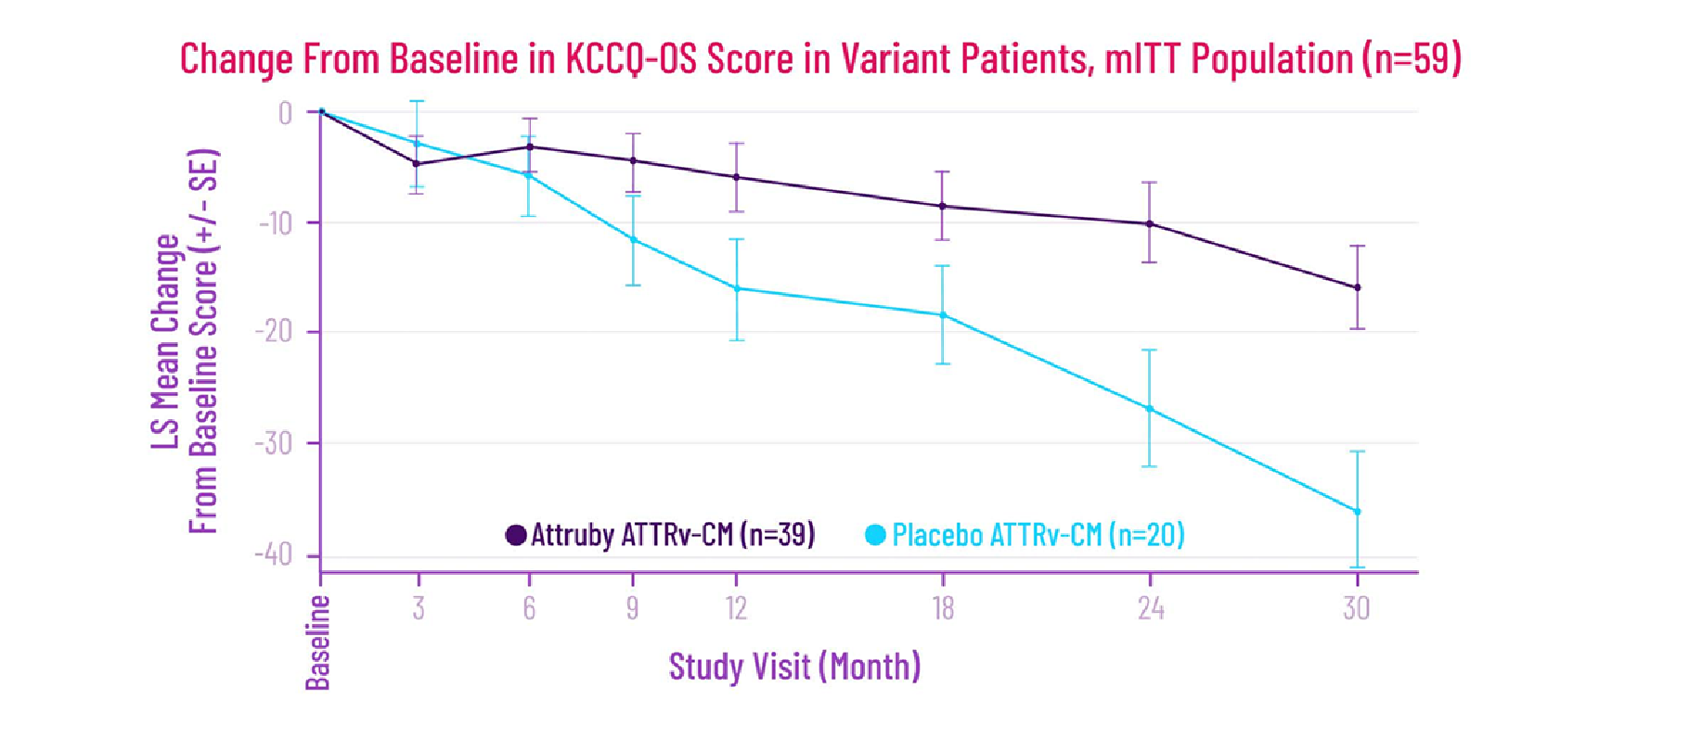
Figure 3-9: Prespecified Subgroup Analysis: Change From Baseline in KCCQ-OS Score in Variant Patients, mITT Population (n=59) [Fontanna Judge 2025 Col 2 Table 1/A, col 2 Figure 2/B]][HCP Attruby iCVA 2.0 Final p43]
In a prespecified subgroup analysis, Attruby treatment showed a clinically meaningful treatment effect on KCCQ-OS score at Month 30 compared to placebo (least-squares mean: 20-point difference; nominal P=0.0019). [Fontanna Judge 2025 Col 2 bullet 6/C] This analysis is descriptive and exploratory in nature. Results are limited by small sample size. This information on subgroup analyses must be called out during a detail.

Functional Capacity (6MWD)
At 30 months, patients treated with Attruby had better 6MWD results than those treated with placebo (Figure 3-10). [Gillmore 2024 p139 Figure3/B]
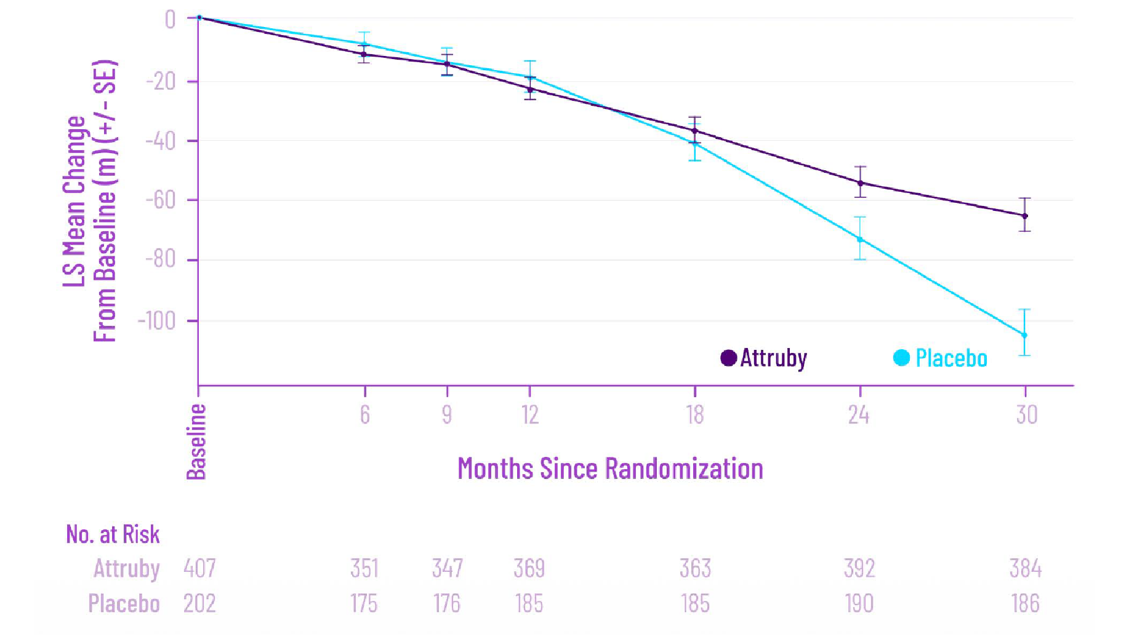
Figure 3-10: Change From Baseline in 6MWD [Gillmore 2024 p139 Figure3/B][HCP Attruby iCVA 2.0 Final p44]
The difference with Attruby compared to placebo in 6MWD change from baseline was approximately 131 feet, or 40 meters (95% CI: 21, 58; P<0.0001). [Attruby PI p7/E]

Improvement in Serum NT-proBNP
Attruby reduced elevation of NT-proBNP, as shown in Figure 3-11; NT-proBNP elevation at Month 30 favored Attruby and was 52.9% of placebo (95% CI: 0.463, 0.604). [Gillmore 2024 p137/B] Elevated levels of NT-proBNP are an indicator of heart stress. [Novack 2025 p1/B]
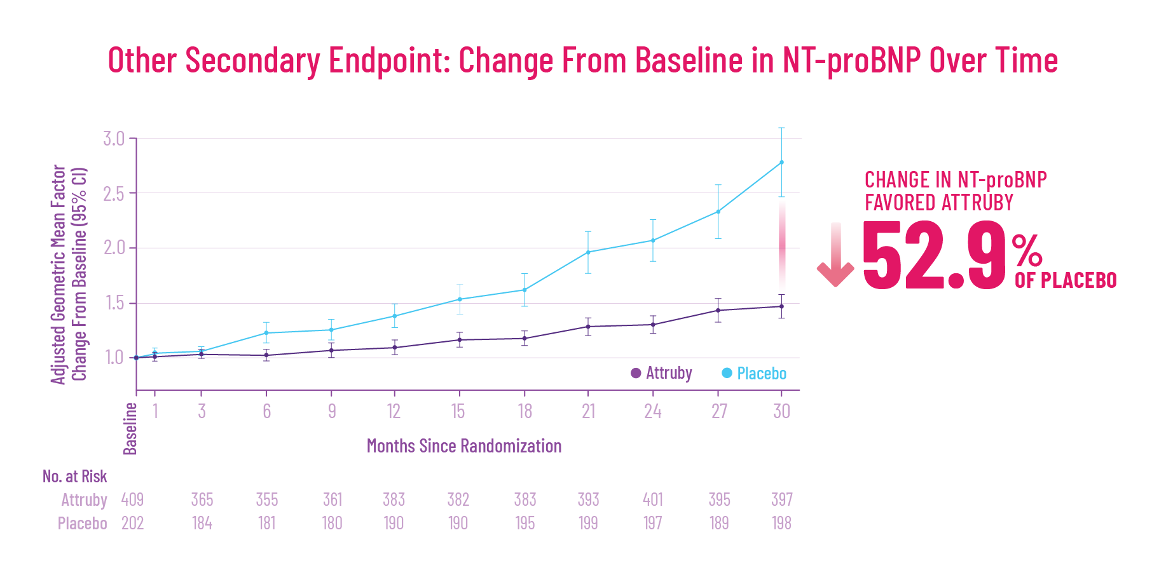
Figure 3-11: Change From Baseline in NT-proBNP Over Time in ATTRibute-CM [Gillmore p139 Fig 3A][HCP Attruby iCVA 2.0 Final p46]

sTTR and Outcomes
In 2 separate post-hoc analyses, early increases in sTTR (5 mg/dL at day 28) were associated with improved outcomes:
- 32% risk reduction in ACM (based on logistic model prediction) [Maurer 2025 p1921/A]
- 25% risk reduction in cardiovascular mortality (based on Cox proportional hazards model) [Maurer 2025 p1921/A]
- 19% risk reduction in CVH (based on Cox proportional hazards model) [Sarswat ACC Poster 2025 col 3 Figure 2/C]
These exploratory analyses are based on ATTRibute-CM participants for whom serum TTR levels were available at baseline and Day 28 and may not fully reflect the broader population. These results may not be generalizable to other TTR stabilizers.

Section 3.4: Open-Label Extension (OLE)
The open label extension (OLE) is being conducted to collect long-term safety data in participants who completed the 30-month double-blind period of the ATTRibute-CM trial (Figure 3-12). [Gillmore 2024 p134/F][Gillmore 2024 supplemental protocol p9/A][Judge Gillmore 2025 p602/A]
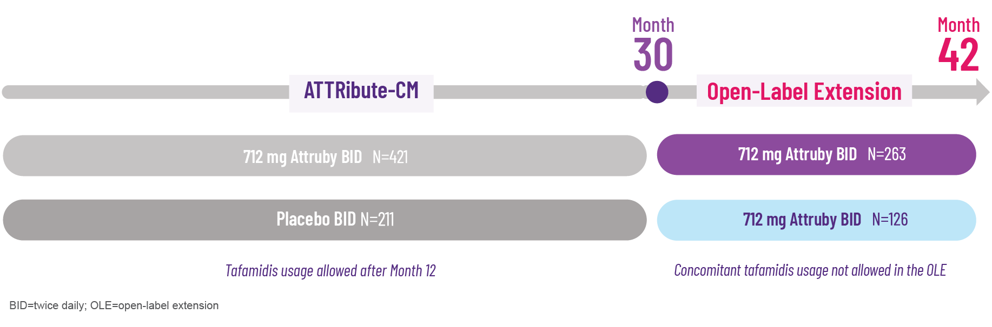
Figure 3-12: ATTRibute-CM and Open-Label Extension [HCP Attruby iCVA 2.0 Final p25]
In the OLE study:
- Participants who previously received placebo were switched to Attruby, while treated patients continued on Attruby. [Judge Gillmore 2025 p603/C] Placebo patients who had added tafamidis after 12 months as allowed per ATTRibute-CM study protocol were required to discontinue tafamidis to rollover to Attruby. [Judge Gillmore 2025 p603/B]
- Secondary objectives included monitoring of clinical outcomes (ACM, CVH, 6MWD, KCCQ-OS). [Judge Gillmore 2025 p603/D, E,F]
The OLE study is unblinded and non-controlled, and included a self-selected population which may have led to baseline imbalance; this non-prespecified, interim analysis was not powered to make definitive conclusions. [Judge Gillmore 2025 p609/A,B] This information should be spoken as part of the detail.
Results from the OLE trial validate observations from ATTRibute-CM (Figure 3-13). [Judge Gillmore 2025 p606/A]
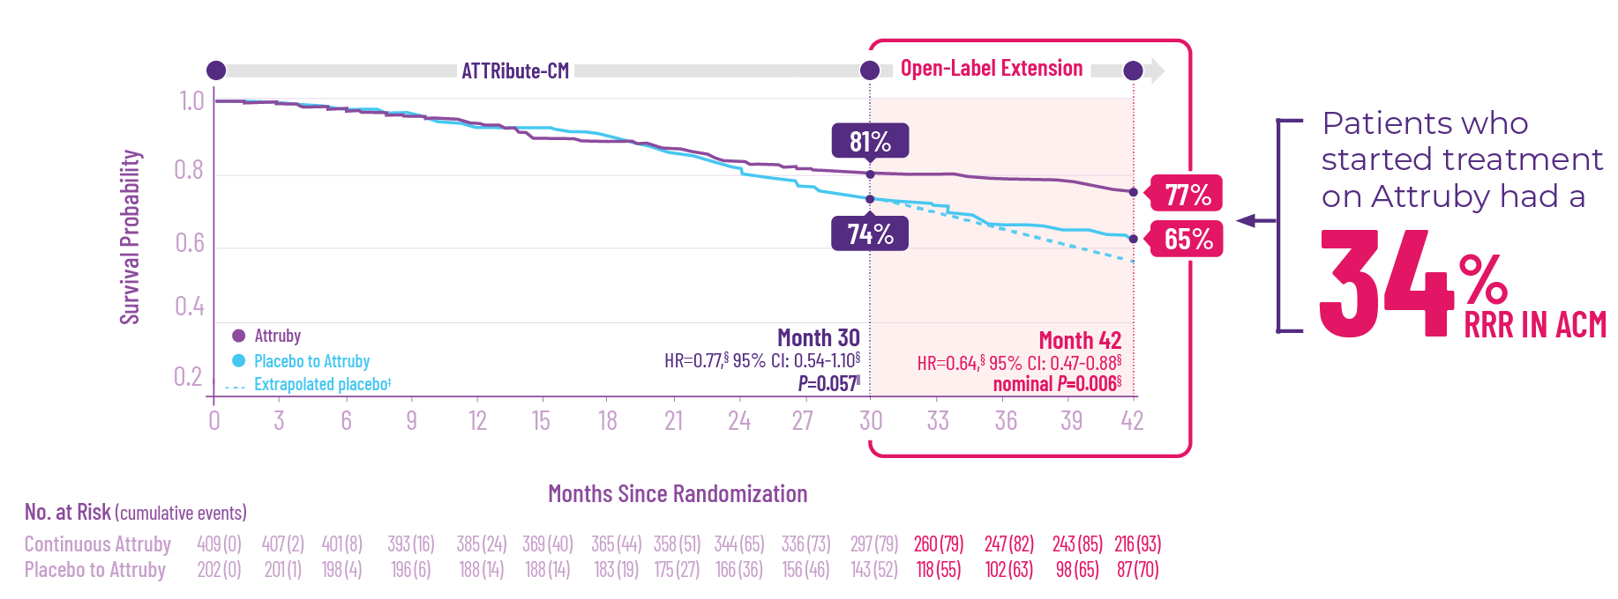

*Data are for the full analysis set, which included the mlTT population in ATTRibute-CM defined as all participants who were randomized to Attruby or placebo, received ≥1 dose of Attruby or placebo, had ≥1 efficacy evaluation after baseline, and had baseline eGFR of ≥30 ml/min/1.73 m². Data were analyzed using a stratified Cox proportional hazards model.
†Expected results if participants had continued receiving placebo in the OLE study. Survival probabilities beyond Month 30, assuming no open-label Attruby had been taken, were extrapolated based on a Weibull probability model for the time to the ACM event estimated from the data observed in the ATTRibute-CM study.
‡Assessed by the Cox proportional hazards model.
§ Assessed by the Cochran-Mantel-Haenszel test.
Figure 3-13: Time to ACM From Baseline Through Month 42* [HCP Attruby iCVA 2.0 Final p37][Judge Gillmore 2025 p604/A, p605 Figure 1/A]

Safety
No new safety concerns were observed in the OLE trial at Month 42. [Judge Gillmore 2025 p606/A]

Key Concepts
Interactivity: Accordion
Accordion 1: Clinical Pharmacology
Attruby acts as a TTR stabilizer. [Attruby PI p5/A][Judge 2019 p289/A,B] It mimics the action of the T119M variant to stabilize the TTR tetramer. [Attruby PI p5/A][Judge 2019 p287/A, p289/A, p290/A,B]
Attruby may decrease free thyroxine levels without changing TSH, likely by reducing thyroxine's binding to or displacement from TTR. [Attruby PI p5/C]
Attruby reduced NT-proBNP increases by about 50% compared to placebo at Month 30 in the ATTR-CM trial. [Attruby PI p5/D]
In the pivotal trial, the increase in troponin I levels was lower with Attruby compared to placebo. [Attruby PI p5/D]
Attruby has no clinically relevant effect on the QTc interval. [Attruby PI p5/E]
Steady-state acoramidis is achieved in about 4 days at the recommended dose of 712 mg twice daily. [Attruby PI p5/F]
Food does not affect acoramidis pharmacokinetics. [Attruby PI p5/H]
Acoramidis has an effective half-life of approximately 6 hours. [Attruby PI p6/A]
The pharmacokinetics of acoramidis do not vary significantly based on age, race/ethnicity, sex, or kidney function. [Attruby PI p6/B]
Attruby should not be administered concomitantly with UGT inducers or strong CYP3A inducers. When Attruby is co-administered with sensitive CYP2C9 substrates, more frequent monitoring of patients for signs of exposure-related toxicity is advised. [Attruby PI p6/C]
There is no evidence of carcinogenicity, mutagenicity, or clastogenicity with acoramidis. [Attruby PI p6/D] Animal studies showed no effects on fertility, reproductive performance or mating behavior of acoramidis on rats. [Attruby PI p7/G]
Accordion 2: Design and Patient Disposition in ATTRibute-CM
ATTRibute-CM was a multicenter, international, randomized, double-blind, placebo-controlled study that evaluated Attruby in 611 adult patients with wild-type or variant ATTR-CM. [Attruby PI p7/A]
Participants were randomly assigned in a 2:1 ratio to receive either 712 mg of Attruby (409 participants) or a placebo (202 participants) twice daily for 30 months. [Gillmore 2024 p135/B,C] [Attruby PI p7/B]
The efficacy analysis was based on the mITT population (n=611) which included all patients who were randomized and received at least one dose of acoramidis or placebo and excluded patients (n=21) with eGFR <30 mL/min/1.73 m². [Gillmore 2024 p135/A, B]
The primary composite endpoint included ACM and cumulative frequency of CVH over 30 months, change from baseline in NT-proBNP, and change from baseline in 6MWD. [Attruby PI 2024 p7/D][Gillmore 2024 p134/C, p135/A]
Key secondary endpoints included change from baseline in 6MWD, KCCQ-OS, and sTTR; ACM, and safety assessments; other secondary endpoints included cardiovascular mortality, cumulative frequency of CVH, and change from baseline in NT-proBNP. [Gillmore 2024 p134/D]
There were no significant differences in baseline characteristics between the treatment groups. [Attruby PI p7/C]
Accordion 3: ATTRibute-CM Efficacy Results
The primary endpoint analysis showed that Attruby significantly reduced the combination of ACM and CVH at Month 30 (P=0.018, assessed using the stratified F-S test). [Attruby PI p7/D]
Attruby showed a rapid observable difference that lasted over time in ACM or CVH. In as early as 3 months, the time-to-first-event Kaplan-Meier curves began separating and diverged through 30 months. [Attruby PI p8 Figure 3/A]
Cox regression showed a 35.5% decrease in risk of ACM or first CVH with Attruby (hazard ratio: 0.645; 95% CI: 0.500, 0.832). [Attruby PI p8/B]
Findings from a post-hoc analysis of ATTRibute-CM data reported a 42% RRR in the composite endpoint of ACM and recurrent CVH. [Judge 2025 p1008.A, Central Illustration/B]
Subgroup analyses showed consistent reductions in ACM or first CVH across both ATTRwt-CM and ATTRv-CM patients. [Davis 2025 poster Results col3 para2/A][HCP Attruby iCVA v2.0 FINAL p34]
  - In ATTRv-CM patients, Attruby achieved a 59% RRR in ACM or first CVH compared to placebo. [Davis 2025 poster Results col 3 Figure 2]
In a secondary endpoint analysis, at 30 months, 81% of patients in the acoramidis group survived compared to 74% of patients in the placebo group. [Attruby PI p7/D]
Compared to placebo, Attruby treatment led to a 50% RRR in the rate of CVH. [Gillmore 2024 p137/A]
Attruby had a significant effect on health-related quality of life (secondary endpoint), achieving a 10-point KCCQ-OS score difference at Month 30 (P<0.0001). [Attruby PI p7/E][Gillmore 2024 p138/B][Spertus 2020 p2382/A, p2384/A]
In ATTRv-CM patients, Attruby produced a 20-point improvement in KCCQ-OS scores (exploratory endpoint) at Month 30 (nominal P=0.0019). [Fontanna Judge 2025 Col 2 bullet 6/C]
Attruby had a significant effect on functional capacity (secondary endpoint), with a 131-foot (40-meter) greater increase in 6MWD compared to placebo (95% CI: 21–58; P<0.0001). [Attruby PI p7/E][Gillmore 2024 p139 Figure3/B]
Attruby reduced NT-proBNP elevation at Month 30 to 52.9% of placebo levels (95% CI: 0.463–0.604). [Gillmore 2024 p137/B][Novack 2025 p1/B]
Post-hoc analyses linked early sTTR increases (≥5 mg/dL at Day 28) with improved outcomes: 32% risk reduction in ACM, 25% in cardiovascular mortality, and 19% in CVH. [Maurer 2025 p1921/A][Sarswat ACC Poster 2025 col 3 Figure 2/C]
Accordion 4: Open-Label Extension (OLE)
In the OLE study, placebo patients switched to Attruby and prior Attruby patients continued treatment, the primary objective was safety and secondary objectives including ACM, CVH, 6MWD, and KCCQ-OS monitoring. [Judge Gillmore 2025 p603/C,D,E,F]
Interim OLE results validated ATTRibute-CM findings, showing benefit through Month 42. [Judge Gillmore 2025 p606/A][Judge Gillmore 2025 p604/A, p605 Figure 1/A]
No new safety concerns were observed in the OLE trial at Month 42. [Judge Gillmore 2025 p606/A]

Check Your Progress
- Acoramidis binds to transthyretin (TTR) at the __________ binding sites.
- dimer
- monomer
- thyroxine (T4)
- hydrogen
- How many patients in the ATTRibute-CM study with transthyretin amyloidosis cardiomyopathy (ATTR-CM) were included in the modified intent-to-treat (mITT) population?
- 311
- 411
- 511
- 611
- Which of the following was included in the composite primary endpoint of ATTRibute-CM?
- Change from baseline in Kansas City Cardiomyopathy Questionnaire-Overall Summary (KCCQ-OS)
- All-cause mortality (ACM) and cumulative frequency of cardiovascular-related hospitalizations (CVH) over 30 months
- Cardiovascular mortality over 30 months
- Safety assessments
- In ATTRibute-CM, separation from placebo in time to all-cause mortality (ACM) or cardiovascular-related hospitalization (CVH) was observed as early as __________ and continued to diverge through to the end of the 30-month study.
- Day 3
- Week 3
- Day 30
- Month 3
- According to the Attruby prescribing information, a Cox regression analysis indicated a _____ decrease in the risk of the composite of all-cause mortality (ACM) or first cardiovascular-related hospitalization (CVH) (hazard ratio: 0.645; 95% confidence interval [CI]: 0.500, 0.832).
- 32.5%
- 35.5%
- 52.5%
- 62.5%
- In ATTRibute-CM, there was a _____ reduction in the cumulative frequency of cardiovascular-related hospitalizations (CVH) among participants treated with acoramidis.
- 30%
- 40%
- 50%
- 60%
- In ATTRibute-CM, an increase in serum transthyretin (sTTR) was observed as early as Day _____ with Attruby treatment.
- 18
- 28
- 38
- 48
- In 2 separate post-hoc analyses, early increases in serum transthyretin (sTTR) were associated with improved outcomes, including lowered relative risk of which of the following? Select all that apply.
- All-cause mortality (ACM)
- Cardiovascular mortality
- Cardiovascular-related hospitalization (CVH)
- Cerebrovascular event
- Which of the following statements about the open-label extension (OLE) to ATTRibute-CM are true? Select all that apply.
- Patients assigned tafamidis during primary 30 months were allowed to rollover to OLE but had to discontinue tafamidis use.
- Placebo patients switched to tafamidis.
- The results validated ATTRibute-CM findings, showing benefit through Month 42.
- No new safety concerns were observed at Month 42.

Answers
- C [Attruby PI p5/B]
- D [Attruby PI p7/A]
- B [Gillmore 2024 p135/D]
- D [ATTTRUBY PI p7/D]
- B [Attruby PI p8/B]
- C [Gillmore 2024 p137/A]
- B [Maurer 2025 p1921/A][Sarswat ACC Poster 2025 col 3 Figure 2/C]
- A, B, C [Maurer 2025 p1921/A][Sarswat ACC Poster 2025 col 3 Figure 2/C]
- A, C, D [Judge Gillmore 2025 p603/C,D,E,F; p606/A; p604/A, p605 Figure 1/A]

Glossary
6-minute walk distance (6MWD) | distance walked on the 6-minute walk test, an assessment to determine fitness, mobility and/or recovery from illness or injury [6MWT Tabers p1/A]
6-minute walk test (6MWT) | assessment to determine fitness, mobility and/or recovery from illness or injury; practical simple test requiring a 100-foot hallway but no exercise equipment or advanced training for technicians; test measures the distance that a patient can quickly walk on a flat, hard surface in 6 minutes (6MWD); used to measure treatment effect, functional status, or risk of morbidity or mortality [6MWT Tabers p1/A][ATS 2002 p1/A, p2 Table 1/A]
aortic stenosis | stenosis of blood flow from the left ventricle to the aorta due to the aortic valve disease or obstructions just above or below the valve [stenosis Tabers p1/A]
atrial fibrillation | most common cardiac dysrhythmia, affecting as many as 5% to 10% of people aged 70 and over; marked by rapid, irregular electrical activity in the atria, resulting in ineffective ejection of blood into the ventricles and an irregular ventricular response (apical pulse rate) [Tabers atrial p1/A]
carpal tunnel syndrome | pain or numbness and tingling affecting a part of the median nerve distribution of the hand (the palmar side of the thumb, the index finger, the radial half of the ring finger, and the radial half of the palm) and may radiate into the arm [Tabers carpal tunnel syndrome p1/A]
clastogenicity | ability to cause chromosomal abnormalities [clastogenic Tabers p1/A]
cohort study | in epidemiology, a study of morbidity or mortality in a cohort, identified at a particular time and followed as the members of the cohort pass through part or all of their lifespan [Tabers study p1/A]
Cox regression analysis | statistical method used to analyze time-to-event data and identify how variables affect the risk (hazard) of an event occurring over time; also called the Cox proportional hazards model [Abd ElHafeez 2021 p1/A, 2/A,B,C]
cytochrome P450 (CYP) | group of enzymes present in every type of cell in the body except red blood cells and skeletal muscle cells; important in metabolizing substances normally present in the body such as steroids, fat-soluble vitamins, fatty acids, prostaglandins, and alkaloids; also detoxifies drugs and a great number of environmental pollutants [Tabers cytochrome P450 p1/A]
enthalpically | in a way that involves or is driven by the heat (energy released or absorbed) content (enthalpy) of a system [enthalpy Tabers p1/A]
estimated glomerular filtration rate (eGFR) | rate of urine formation as plasma passes through the renal glomeruli; chronic kidney disease can be classified into stages based on eGFR; stage 1 indicates normal filtration (eGFR ≥90) but with signs of damage, Stage 2 shows mild loss (eGFR 60–89) with evidence of injury, Stage 3 is split into 3a (eGFR 45–59) and 3b (eGFR 30–44), representing moderate decline, Stage 4 (eGFR 15–29) signals severe impairment, and Stage 5 (eGFR <15) is considered kidney failure, often requiring dialysis or transplant [Tabers rate p3/A] [Tabers eGFR p1/A][American Kidney Fund p3/A]
glucuronidation | metabolic process by which drugs or other substances are combined with glucuronic acid to form more water-soluble compounds, which are more readily excreted by the kidneys or in bile [APA Dictionary p1/A]
heart failure with preserved ejection fraction (HFpEF) | signs and symptoms of heart failure, including dyspnea, orthopnea or nocturnal dyspnea, and radiological evidence of pulmonary congestion, but an ejection fraction that is greater than 50% [HFpEF Tabers p1/A]
hereditary (variant) transthyretin amyloidosis (ATTRv) | form of ATTR-CM caused by destabilizing amino acid variants in the transthyretin (TTR) protein, which prevents the formation of stable TTR tetramers and facilitates the development of amyloid fibrils [Kittleson 2020 p e7/A, B, p e13/A]
immunoglobulin light chain (AL) amyloidosis | amyloidosis in which immunoglobulin light chains (or parts of light chains) circulate in serum and deposit in tissues such as the kidneys; may cause significant organ dysfunction; light chain amyloid requires urgent diagnosis and represents immediate risk of death, serious impairment of bodily functions, or permanent organ damage if not treated early in the disease course [amyloidosis Tabers p1/A][AL Amyloidosis p1/A, 2.A, 3/A, 9/A]
inducer | in chemistry, a compound that increases the concentration of another molecule [Tabers inducer p1/A]
infiltrative cardiomyopathy | cardiomyopathy that results from the accumulation of substances within the myocardium that impair the heart’s ability to eject blood [infiltrative cardiomyopathy Tabers p3/A]
intent-to-treat | clinical trial in which results from all randomized patients are included whether or not they actively participated in the complete study; the modified intent-to-treat (mITT) in the ATTRibute-CM trial included all patients who were randomized and received at least one dose of acoramidis or placebo and excluded patients (n=21) with eGFR <30 mL/min/1.73 m². [Gillmore 2024 p135/A, B] [CVA p12/B][intent to treat Tabers p1/A]
monomer | molecule that can be bound to similar molecules to form a polymer [Tabers monomer p1/A]
mutagenicity | ability to induce a genetic mutation [mutagenesis Tabers p1/A]
N-terminal prohormone of brain natriuretic peptide (NT-proBNP) | biologically inactive peptide that is formed as a byproduct of brain natriuretic peptide activation; levels rise in cardiac disease [Novack 2025 p1/A, p4/A]
New York Heart Association (NYHA) Class | description from New York Heart Association of heart failure according to four classes; Class 1 is asymptomatic, but there is risk because of hypertension with evidence of organ stress; Class 2 is mildly symptomatic during significant exertion; Class 3 is moderately symptomatic during light exertion; and in Class 4 the patient is unable to leave the room or bed without severe shortness of breath [NYHA Tabers p1/A]
observational study | study in which the results are obtained retrospectively or without a control group; some examples include case reports, chart reviews, and longitudinal studies of large cohorts followed over time [Tabers study p3/A]
scintigraphy | injection and subsequent detection of radioactive isotopes, such as technetium-99M pyrophosphate (PYP) or others, to create images of body parts and identify body functions and diseases [scintigraphy Tabers p1/A][Kittleson 2025 p7/A]
T119M (p.T149M) | transthyretin (TTR) variant that has the highest TTR tetramer stability and which has been shown to stabilize both wild-type and variant TTR tetramers and thereby help prevent formation of amyloids; [Greve 2020 p260/C] note that p.T139M and T119M are different names for the same TTR variant using different nomenclature systems; [Greve 2020 p260/B] the “p.” in p.T139M refers to precursor in the newer nomenclature, which also adds 20 to the amino acid position from the legacy nomenclature (eg, T119M in the legacy nomenclature plus the “p.” for precursor plus 20 to the amino acid position 119 becomes p.T139M in the newer nomenclature)
tafamidis | transthyretin (TTR) stabilizer produced by Pfizer approved in 2022 [Kittleson 2023 p1087/B]
technetium-99m (99mTc) | radioactive isotope of technetium having a half-life of 6 hours, in which the “m” means that it is a metastable isotope; 99mTc is used in nuclear medicine for a wide variety of diagnostic tests and imaging studies [Tabers technetium-99m p1/A]
tetramer | structure such as a molecule or a polymer made of 4 structural subunits [Tabers tetramer p1/A]
transthyretin (TTR) | also known as prealbumin; key transport protein for retinol binding protein (vitamin A) and thyroxine (thyroid hormone) in the blood; TTR is primarily produced in the liver and adopts a tetrameric structure to transport cargo through the body [Liz 2020 p396/A, p397/A][Vieira 2014 p45/A, B]
thyroxine (T4) | principal hormone secreted by the thyroid gland that increases the use of all food types for energy production and increases the rate of protein synthesis in most tissues [Tabers thyroxine p1/A]
transthyretin amyloidosis cardiomyopathy (ATTR-CM) | also known as transthyretin amyloid cardiomyopathy (ATTR-CM); rare, progressive infiltrative cardiomyopathy that mimics hypertensive, hypertrophic heart disease; results from destabilization of the transthyretin (TTR) protein, which allows TTR tetramers to break apart into monomers that can misfold into toxic amyloid fibrils, leading to the accumulation of TTR amyloid fibrils in the myocardium [Kittleson 2020 p e7/A, e8/A.B, p e11/A, p e13/A][Garcia-Pavia 2021 p896/B]
UDP-glucuronosyltransferase (UGT) | group of enzymes that play a role in drug metabolism [Allain 2020 p1277/A]
vitamin A | fat-soluble vitamin formed within the body; essential for normal growth and development, normal function and integrity of epithelial tissues, formation of visual pigment [vitamin A Tabers p1/A]
wild-type transthyretin amyloidosis (ATTRwt) | form of ATTR-CM in which spontaneous destabilization of the transthyretin (TTR) protein occurs due to aging; this destabilization prevents the formation of stable TTR tetramers, facilitating the development of amyloid fibrils [Kittleson 2020 p e13/A]

References
- Abd ElHafeez S, D’Arrigo G, Leonardis D, Fusaro M, Tripepi G, Roumeliotis S. Methods to analyze time-to-event data: the Cox regression analysis. Oxid Med Cell Longev. 2021;2021(1):1302811. doi:10.1155/2021/1302811 [Abd ElHafeez 2021]
- AL amyloidosis (primary amyloidosis). Cleveland Clinic. Updated June 24, 2022. Accessed November 7, 2025. https://my.clevelandclinic.org/health/diseases/15718-amyloidosis-al-amyloid-light-chain [AL Amyloidosis]
- Andrade C. The practical importance of half-life in psychopharmacology. J Clin Psychiatry. 2022;83(4):22f14584. https://www.psychiatrist.com/jcp/importance-of-half-life-in-psychopharmacology/ [Andrade 2022]
- APA dictionary of psychology. American Psychological Association. Accessed December 2025. https://dictionary.apa.org [APA dictionary]
- ATS Committee on Proficiency Standards for Clinical Pulmonary Function Laboratories. ATS statement: guidelines for the six-minute walk test. Am J Respir Crit Care Med. 2002;166(1):111-117. doi:10.1164/ajrccm.166.1.at1102 [ATS 2002]
- Attruby (acoramidis) tablets for oral administration. Prescribing information. BridgeBio Pharma; 2024. [Attruby PI]
- Bhatt K, Delgado DH, Khella S, et al. Hereditary transthyretin amyloidosis in patients referred to a genetic testing program. J Am Heart Assoc. 2024;13(23):e033770. doi:10.1161/JAHA.123.033770 [Bhatt 2024]
- Boda I, Farhoud H, Dalia T, Goyal A, Shah Z, Vidic A. Early and aggressive presentation of wild-type transthyretin amyloid cardiomyopathy: a case report. World J Cardiol. 2022;14(12):657-664. doi:10.4330/wjc.v14.i12.657 [Boda 2022]
- Buxbaum JN, Ruberg FL. Transthyretin V122I (pV142I)* cardiac amyloidosis: an age-dependent autosomal dominant cardiomyopathy too common to be overlooked as a cause of significant heart disease in elderly African Americans. Genet Med. 2017;19(7):733-742. doi:10.1038/gim.2016.200 [Buxbaum 2017]
- Cambridge Dictionary. Stepwise. Accessed March 22, 2025. https://dictionary.cambridge.org/us/dictionary/english/stepwise [Cambridge stepwise definition]
- Christoffersen M, Greve AM, Hornstrup LS, Frikke-Schmidt R, Nordestgaard BG, Tybjærg-Hansen A. Transthyretin tetramer destabilization and increased mortality in the general population. JAMA Cardiol. 2025;10(2):155-163. doi:10.1001/jamacardio.2024.4102 [Christofferson 2024]
- Data on file. Sales Training. Attruby CVA. 2.0. TSS Training. September 5, 2025. ©2025 BridgeBio Pharma Inc. MAT-US-ACO-0203V2. [HCP Attruby iCVA v2.0 FINAL]
- Davis MK, Alexander KM, Ambardekar A, et al. Acoramidis increases serum TTR levels in patients with wild-type or variant transthyretin amyloid cardiomyopathy. Presented at: the American College of Cardiology 74th Annual Scientific Session and Expo; March 29-31, 2025; Chicago, IL. [Davis 2025]
- Fontana M, Kumar V, Sheridan P, et al. Unmet need in a contemporary cohort of tafamidis-treated transthyretin amyloid cardiomyopathy patients. J Card Fail. 2025;31(1):318. doi:10.1016/j.cardfail.2024.10.349 [Fontanna 2025]
- Fontana M, Judge DP, Gillmore JD, et al. Effect of acoramidis on functional capacity and quality of life in patients with variant ATTR-CM: results from ATTRibute-CM. Poster presented at: Heart Failure 2025, ESC-HF Congress; April 17–20, 2025; Belgrade, Serbia. [Fontana Judge 2025]
- Garcia-Pavia P, Bengel F, Brito D, et al. Expert consensus on the monitoring of transthyretin amyloid cardiomyopathy. Eur J Heart Fail. 2021;23(6):895-905. doi:10.1002/ejhf.2198 [Garcia-Pavia 2021]
- Gertz MA, Benson MD, Dyck PJ, et al. Diagnosis, prognosis, and therapy of transthyretin amyloidosis. J Am Coll Cardiol. 2015;66(21):2451-2466. doi:10.1016/j.jacc.2015.09.075 [Gertz 2015]
- Gillmore JD, Judge DP, Cappelli F, et al. Efficacy and safety of acoramidis in transthyretin amyloid cardiomyopathy. N Engl J Med. 2024;390(2):132-142. doi:10.1056/NEJMoa2305434 [Gillmore 2024]
- Gillmore JD, Judge DP, Cappelli F, et al. Efficacy and safety of acoramidis in transthyretin amyloid cardiomyopathy. N Engl J Med. 2024;390(2):132-142. Appendix. doi:10.1056/NEJMoa2305434 [Gillmore 2024 Appendix]
- Gillmore JD, Judge DP, Cappelli F, et al. Efficacy and safety of acoramidis in transthyretin amyloid cardiomyopathy. N Engl J Med. 2024;390(suppl 7):732-742. doi:70.7056/N EJ Moa2305434 [Gillmore 2024 supplemental protocol]
- Greve AM, Christoffersen M, Frikke-Schmidt R, Nordestgaard BG, Tybjærg-Hansen A. Association of low plasma transthyretin concentration with risk of heart failure in the general population. JAMA Cardiol. 2021;6(3):258-266. doi:10.1001/jamacardio.2020.5969 [Greve 2021]
- Griffin JM, Rosenthal JL, Grodin JL, Maurer MS, Grogan M, Cheng RK. ATTR amyloidosis: current and emerging management strategies. JACC CardioOncol. 2021;3(4):488-505. doi:10.1016/j.jaccao.2021.06.006 [Griffin 2021]
- Hafeez AS, Bavry AA. Diagnosis of transthyretin amyloid cardiomyopathy. Cardiol Ther. 2020;9(1):85-95. doi:10.1007/s40119-020-00169-4 [Hafeez 2020]
- Hammarström P, Jiang X, Hurshman AR, Powers ET, Kelly JW. Sequence-dependent denaturation energetics: A major determinant in amyloid disease diversity. PNAS. 2002;99(suppl_4):16427-16432. doi:10.1073/pnas.202495199 [Hammarstrom 2002]
- Hallare J, Gerriets V. Elimination half-life of drugs. In: StatPearls [Internet]. StatPearls Publishing; 2025. Updated May 3, 2025. Accessed January 5, 2026. http://www.ncbi.nlm.nih.gov/books/NBK554498/ [Hallare 2025]
- Hanson JLS, Arvanitis M, Koch CM, et al. Use of serum transthyretin as a prognostic indicator and predictor of outcome in cardiac amyloid disease associated with wild-type transthyretin. Circ Heart Fail. 2018;11(2):e004000. doi:10.1161/CIRCHEARTFAILURE.117.004000 [Hanson 2018]
- Ioannou A, Patel RK, Razvi Y, et al. Impact of earlier diagnosis in cardiac ATTR amyloidosis over the course of 20 years. Circulation. 2022;146(22):1657-1670. doi:10.1161/CIRCULATIONAHA.122.060852 [Ioannou 2022]
- Judge DP, Heitner SB, Falk RH, et al. Transthyretin stabilization by AG10 in symptomatic transthyretin amyloid cardiomyopathy. J Am Coll Cardiol. 2019;74(3):285-295. doi:10.1016/j.jacc.2019.03.012 [Judge 2019]
- Judge DP, Alexander KM, Cappelli F, et al. Efficacy of acoramidis on all-cause mortality and cardiovascular hospitalization in transthyretin amyloid cardiomyopathy. J Am Coll Cardiol. 2025;85(10):1003-1014. doi:10.1016/j.jacc.2024.11.042 [Judge 2025]
- Judge DP, Gillmore JD, Alexander KM, et al. Long-term efficacy and safety of acoramidis in ATTR-CM: initial report from the open-label extension of the ATTRibute-CM trial. Circulation. 2025;151(9):601-611. doi:10.1161/CIRCULATIONAHA.124.072771 [Judge Gillmore 2025]
- Kanefendt F, Dallmann A, Chen H, et al. Assessment of the CYP3A4 induction potential by carbamazepine: insights from two clinical DDI studies and PBPK modeling. Clin Pharmacol Ther. 2024;115(5):1025-1032. doi:10.1002/cpt.3151 [Kanefendt 2024]
- Kittleson MM, Maurer MS, Ambardekar AV, et al. Cardiac amyloidosis: evolving diagnosis and management: a scientific statement from the American Heart Association. Circulation. 2020;142(1):e7-e22. doi:10.1161/CIR.0000000000000792 [Kittleson 2020]
- Kittleson MM, Panjrath GS, Amancherla K, et al. 2023 ACC expert consensus decision pathway on management of heart failure with preserved ejection fraction: a report of the American College of Cardiology Solution Set Oversight Committee. J Am Coll Cardiol. 2023;81(18):1835-1878. doi:10.1016/j.jacc.2023.03.393 [Kittleson 2023]
- Kittleson MM, Ambardekar AV, Cheng RK, et al. Transthyretin cardiac amyloidosis evaluation and management: 2025 ACC Concise Clinical Guidance. J Am Coll Cardiol. 2025:S0735-1097(25)07719-8. doi:10.1016/j.jacc.2025.09.004 [Kittleson 2025]
- Lane T, Fontana M, Martinez-Naharro A, et al. Natural history, quality of life, and outcome in cardiac transthyretin amyloidosis. Circulation. 2019;140(1):16-26. doi:10.1161/CIRCULATIONAHA.118.038169 [Lane 2019]
- Lauppe R, Liseth Hansen J, Fornwall A, et al. Prevalence, characteristics, and mortality of patients with transthyretin amyloid cardiomyopathy in the Nordic countries. ESC Heart Failure. 2022;9(4):2528-2537. doi:10.1002/ehf2.13961 [Lauppe 2022]
- Liz MA, Coelho T, Bellotti V, Fernandez-Arias MI, Mallaina P, Obici L. A narrative review of the role of transthyretin in health and disease. Neurol Ther. 2020;9(2):395-402. doi:10.1007/s40120-020-00217-0 [Liz 2020]
- Maurer MS, Bokhari S, Damy T, et al. Expert consensus recommendations for the suspicion and diagnosis of transthyretin cardiac amyloidosis. Circ Heart Fail. 2019;12(9):e006075. doi:10.1161/CIRCHEARTFAILURE.119.006075 [Maurer 2019]
- Maurer MS, Judge DP, Gillmore JD, et al. Early increase in serum transthyretin by acoramidis independently predicts improved survival in TTR amyloid cardiomyopathy. J Am Coll Cardiol. 2025;85(20):1911-1923. doi:10.1016/j.jacc.2025.03.542 [Maurer 2025]
- Miller M, Pal A, Albusairi W, et al. Enthalpy-driven stabilization of transthyretin by AG10 mimics a naturally occurring genetic variant that protects from transthyretin amyloidosis. J Med Chem. 2018;61(17):7862-7876. doi:10.1021/acs.jmedchem.8b00817 [Miller 2018]
- Morfino P, Aimo A, Vergaro G, et al. Transthyretin stabilizers and seeding inhibitors as therapies for amyloid transthyretin cardiomyopathy. Pharmaceutics. 2023;15(4):1129. doi:10.3390/pharmaceutics15041129 [Morfino 2023]
- Momper JD, Venkataramanan R, Jantz AS, et al. Evaluation of effective half-life and its impact on time to steady state for oral MeltDose Tacrolimus (LCPT) in de novo kidney transplant recipients. Ther Drug Monit. 2025;47(1):169-173. doi:10.1097/FTD.0000000000001270 [Momper 2025]
- Nativi-Nicolau JN, Karam C, Khella S, Maurer MS. Screening for ATTR amyloidosis in the clinic: overlapping disorders, misdiagnosis, and multiorgan awareness. Heart Fail Rev. 2022;27(3):785-793. doi:10.1007/s10741-021-10080-2 [Nativi 2022]
- Niemietz C, Chandhok G, Schmidt H. Therapeutic oligonucleotides targeting liver disease: TTR amyloidosis. Molecules. 2015;20(10):17944-17975. doi:10.3390/molecules201017944 [Niemietz 2010]
- Novack ML, Zubair M. Natriuretic peptide B type test. In: StatPearls [Internet]. StatPearls Publishing; 2025. Updated August 2, 2025. Accessed October 9, 2025. http://www.ncbi.nlm.nih.gov/books/NBK556136/ [Novack 2025]
- Obi CA, Mostertz WC, Griffin JM, Judge DP. ATTR epidemiology, genetics, and prognostic factors. Methodist Debakey Cardiovasc J. 2022;18(2):17-26. doi:10.14797/mdcvj.1066 [Obi 2022]
- Penchala SC, Connelly S, Wang Y, et al. AG10 inhibits amyloidogenesis and cellular toxicity of the familial amyloid cardiomyopathy-associated V122I transthyretin. Proc Natl Acad Sci. 2013;110(24):9992-9997. doi:10.1073/pnas.1300761110 [Penchala 2013]
- Rozenbaum MH, Large S, Bhambri R, et al. Impact of delayed diagnosis and misdiagnosis for patients with transthyretin amyloid cardiomyopathy (ATTR-CM): a targeted literature review. Cardiol Ther. 2021;10(1):141-159. doi:10.1007/s40119-021-00219-5 [Rozenbaum 2021]
- Ruberg FL, Grogan M, Hanna M, Kelly JW, Maurer MS. Transthyretin amyloid cardiomyopathy: JACC State-of-the-Art Review. J Am Coll Cardiol. 2019;73(22):2872-2891. doi:10.1016/j.jacc.2019.04.003 [Ruberg 2019]
- Ruberg FL, Maurer MS. Cardiac amyloidosis due to transthyretin protein. JAMA. 2024;331(9):778-791. doi:10.1001/jama.2024.0442 [Ruberg 2024]
- Sanguinetti C, Minniti M, Susini V, et al. The journey of human transthyretin: synthesis, structure stability, and catabolism. Biomedicines. 2022;10(8):1906. doi:10.3390/biomedicines10081906 [Sanguinetti 2022]
- Sant’Anna R, Almeida MR, Varejāo N, et al. Cavity filling mutations at the thyroxine-binding site dramatically increase transthyretin stability and prevent its aggregation. Sci Rep. 2017;7(1):44709. doi:10.1038/srep44709 [Santanna 2017]
- Sarswat N, Ambardekar A, Taubel J, et al. Acoramidis-mediated early increase in serum transthyretin level reduces cardiovascular-related hospitalizations and mortality: insights from the ATTRibute-CM study. Presented at: The American College of Cardiology 74th Annual Scientific Session & Expo, March 29–31, 2025; Chicago, IL, USA. [Sarswat 2025]
- Shaker N, Tynski Z, Hudak M, Brown RR, Qasem S, Parwani A. Primary localized amyloidosis of the ureter with osseous metaplasia presenting as a suspicious ureteral mass. Urol Case Rep. 2021;41:101967. doi:10.1016/j.eucr.2021.101967 [Shaker 2022]
- Spertus JA, Jones PG, Sandhu AT, Arnold SV. Interpreting the Kansas City Cardiomyopathy Questionnaire in clinical trials and clinical care: JACC State-of-the-Art Review. J Am Coll Cardiol. 2020;76(20):2379-2390. doi:10.1016/j.jacc.2020.09.542 [Spertus 2020]
- Stages of kidney disease (CKD). American Kidney Fund. Updated July 21, 2025. Accessed November 7, 2025. https://www.kidneyfund.org/all-about-kidneys/stages-kidney-disease [American Kidney Fund]
- Stewart M, Shaffer S, Murphy B, et al. Characterizing the high disease burden of transthyretin amyloidosis for patients and caregivers. Neurol Ther. 2018;7(2):349-364. doi:10.1007/s40120-018-0106-z [Stewart 2018]
- Taber’s Medical Dictionary Online. Unbound Medicine. Accessed March 19, 2025. https://www.tabers.com/tabersonline/ [Tabers]
- Tziomalos G, Zegkos T, Baltagianni E, et al. Transthyretin amyloid cardiomyopathy: current diagnostic approach and risk stratification with multimodality imaging. J Clin Med. 2025;14(6):2014. doi:10.3390/jcm14062014 [Tziomalos 2015]
- U.S. Food and Drug Administration (FDA). Medical Device Development Tools (MDDT). Updated May 16, 2024. Accessed October 27, 2024. https://www.fda.gov/medical-devices/medical-device-development-tools-mddt [FDA 2024]
- Vieira M, Saraiva MJ. Transthyretin: a multifaceted protein. Biomol Concepts. 2014;5(1):45-54. doi:10.1515/bmc-2013-0038 [Vieira 2014]
- Vyndaqel and Vyndamax. Prescribing information. Pfizer Inc; 2023. [Tafamidis PI]
- Witteles RM, Bokhari S, Damy T, et al. Screening for transthyretin amyloid cardiomyopathy in everyday practice. JACC Heart Fail. 2019;7(8):709-716. doi:10.1016/j.jchf.2019.04.010 [Witteles 2019]
- Wright WC, Chenge J, Chen T. Structural perspectives of the CYP3A family and their small molecule modulators in drug metabolism. Liver Res. 2019;3(3):132-142. doi:10.1016/j.livres.2019.08.001 [Wright 2019]

